The Meerkatter

The Friends of the Kalahari Meerkat Project Report – www.kalahari-meerkats.com – January 2019
Chaos at Creatures…...……………………………………… | 1-2 |  | Weather at the KMP……………………….………………… | 3
Shocking Discoveries……………………..……………………. | 2 |  | Life History Details …………………………………………… | 3-5
Pregnancies in January……………………………………… | 2 |  | Group Territories January 2019 | 6

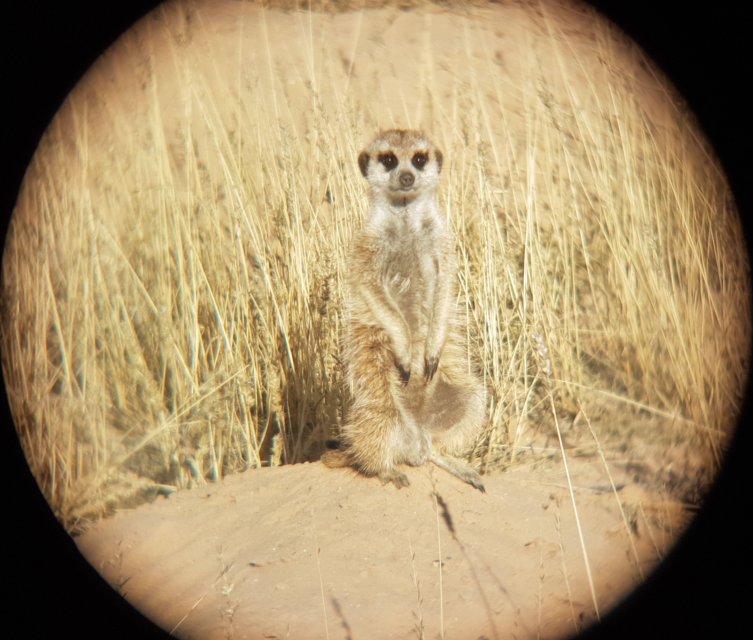

Chaos at Creatures
January has been a very eventful month for the members of Little Creatures, keeping our volunteers busy. Kanye (VCRM002) had decided to pack his bags and to explore and visit a few neighboring meerkat groups. After a quick roving excursion at Hakuna Matata to end 2018, he came back to Run Amuk where he was recently immigrated in. But this was only for a short period of time, as Kanye was emigrated out of Run Amuk to rejoin his natal group Little Creatures mid-January.

Kanye (VCRM002) at a Little Creatures burrow upon his return to the group. Photo Credit: KMP volunteer Rebecca Schaefer

This is the time when the group decided to split, the famous LL Cool J (VLM207), Calpurnia (VCRF001) and two yearling females were found to be away from the dominant male Watu Porini (VJXM104), an adult female, a yearling female and a sub-adult male by Meerkat volunteer and awesome Life History volunteer Lorna Harvey. Two different volunteers were sent to Little Creatures in order to report on dominance within the two different subgroups, but also to keep working on their habituation. Luckily, two individuals were collared, Calpurnia (VCRF001) and Kanye (VCRM002), and each one of them happened to act as part of a different groups, making it possible to track them both in the morning to reach their sleeping burrows before them waking up.

LLCOOLJ (VLM207) waking up with Little Creatures. Photo Credit: Former volunteer Steph Williams.

The situation must have sounded too easy to Kanye (VCRM002), as he chose to leave his group once more, and has been seen roving at Jaxx more than once, coming back to his home group from time to time and forcing volunteers to walk around and visit previous sleeping burrows hoping to find the individuals away from Little Creatures, as they were unable to track them without the presence of the collared rover.

Very interesting interactions have been observed, with the original dominant male Watu Porini (VJXM104) acting dominant with the real Little Creatures group, and LL Cool J (VLM207) displaying dominant behaviors in the group he was part of. As long term readers may remember, LL Cool J (VLM207) was first seen in 2013 and became dominant at Lazuli soon after for more than two year. He then surprisingly decide to leave his group and got accepted into Jaxx, where he overthrew his son Leonard (VLM221) and took over dominance, a position he held for over a year. But Leonard (VLM221) having reached his full adult size, he was able to defeat LL Cool J (VLM207) that decided to leave once more and approached Little Creatures, he got accepted but did not win the dominance competitions. Acting dominant with the individuals he took away from Watu Porini (VJXM104) could have been another attempt for him to regain a throne and assert dominance on a group.

But once again, this situation did not last for a very long time. LL Cool J (VLM207) left Calpurnia (VCRF001) and the two sub-adult females to approach Little Creatures led by Watu Porini (VJXM104), trying to be accepted back in the group. It did not turn out as well as he would have hoped, our unsuccessful subordinate had been seen waking up at the same sleeping burrows but was chased away or left before the group even woke up. The end of January was not calmer for this habituation group, Calpurnia (VCRF001) was sadly found predated by Meerkat volunteer Melissa Wharram on the 29th, LL Cool J (VLM207) is still not acting as part of the group, and Kanye (VCRM002) left Little Creatures and has last been seen roving at Jaxx.

We are now all wondering if Little Creatures is going to go back to its former calm and settled situation, or if the chaos is going to continue into February.

Shocking Discoveries
At the end of last month, 15 females remained pregnant, but this figure did not include those of 3 subordinate females that were shockingly discovered being pregnant at the beginning of January. These three subordinates are actually sub-adults ranging from 8-9months old, including Make-e-plan females Moo (VMPF019) and Toscana (VMPF020), as well as Ubuntu subordinate Meticulous Brown (VUBF019).
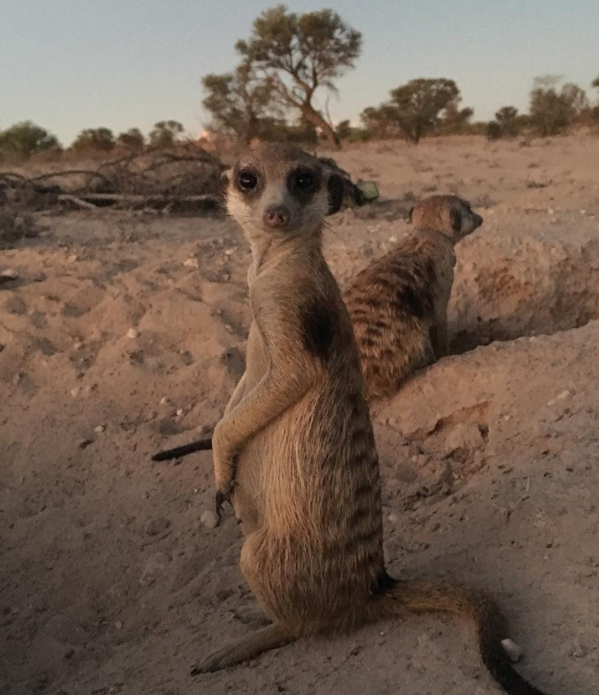

Ubuntu sub-adult female Meticulous Brown (VUBF019) looking heavily pregnant at the end of the month. Photo Credit: KMP volunteer, Jess Granweiler.

The volunteers were in constant denial as it is so unusual for such young females to become pregnant. But as the New Year was fast approaching, these sub-adults were looking even rounder and bigger and it was becoming impossible to ignore it any longer.

This is not the first time the KMP has had sub-adult females getting pregnant this year. Loyal readers may remember that back in September former Run Amuk dominant female Gypsy (VRUF005) was made pregnant when she was 8 months old whilst she was still a subordinate. Unfortunately she lost her litter and so did her sister Bean (VRUF001), even though she was pregnant as a dominant and a few months older.

Subordinate females are usually able to breed from 1 year of age, but these reproductive attempts are uncommon and usually unsuccessful due to suppression by the dominant female, usually by eviction from the group or infanticide. This behavioural suppression is not known to stop subordinate reproductive cycles all together, but evicted females do suffer from high levels of stress hormones, which is associated with reduced conception rates and increased abortions.

Due to their pregnancies does this mean that these young females, Moo (VMPF019), Toscana (VMPF020) and Meticulous Brown (VUBF019), would get evicted?

Fortunately not so far, as Toscana (VMPF020) aborted her pregnancy early on in the month, and just 10 days later, her sister Moo (VMPF019) also aborted hers. It is very likely that both mated with Dominant male Le Grand Obstacle (VVHM103) as he is unrelated to them. Dominant males are not picky with which females they mate with, they take the opportunity to pass on their genes whenever possible.

At the end of the month, Ubuntu female Meticulous Brown (VUBF019) remains pregnant, and volunteers are confident that she will reach full-term. But with Dominant female Daisy (VBBF111) having a reputation for infanticide, including her most recent litter and potentially the recent litters from subordinate females Minusch (VBBF109) and Etosha (VUBF005), it is very unlikely that her litter will survive if she gave birth within the group.
Volunteers remain concerned that as Meticulous Brown’s (VUBF019) pregnancy continues, she will be evicted by dominant female Daisy. For such a young female and having no experience with such a situation, it is likely she will not cope well with the eviction, increasing her stress levels and increasing the likelihood of losing her litter. Volunteers are keeping a close eye on the sub-adult as February begins.

Pregnancies in January 2019

Females pregnant in January | 23
Females who aborted | 5
Females who gave birth, litters lost | 10
Females who gave birth, litter emerged | 0
Females who gave birth, unknown outcome | 3
Females still pregnant at the end of the month | 5

Weather at the KMP

The start to the New Year got off on a warm start with temperatures reaching a high of 41.8ºC. But the summer nights were getting even colder with the lowest temperature reaching a chilly 8.6 ºC. Rain still blessed the reserve with us receiving a total of 15.8mm for the month.

January 2019 Life History Details

(Little) Creatures:
- Kanye (VCRM002) was still on the move and left Run Amuk before immigrating back to Creatures. He did go roving and approached Jaxx, and has not returned to his home group yet.
- The group split during this past month, with LL Cool J (VLM207), Calpurnia (VCRF001) and two yearling females being away from dominant male Watu Porini (VJXM104). LL Cool J (VLM207) was not back with the group at the end of January.
- Calpurnia (VCRF001) has been found dead on the 29th of January.
- Habituation has been stable at Little Creatures, volunteers are going to push a little bit further in order to get closer to the group and to get them interested in egg.
- All members are in good health.

Elrond’s Council:
- Two pups of Tayl Baez’s (VBBF117) litter disappeared early on, two other pups went missing and are yet to be seen, but VECM006 is still successfully foraging with the group and is very well habituated.
- The group split for an uncertain duration, with Kamala (VBBF116), Mouse (VECF1), one of the pups (VECM007), the dominant male, one sub-adult male and one sub-adult female 1SAM away from the dominant female Tayl Baez. They all came back to their group safely.
- Habituation is still improving, the sub-adults are very interested in egg and the dominant male is getting comfortable at a shorter distance. The pup loves egg and is climbing in the scales box by himself.
- The group is in good health.

Freetails:
- Dominant female Floob (VLF227) has been seen with up to four wild males this month.
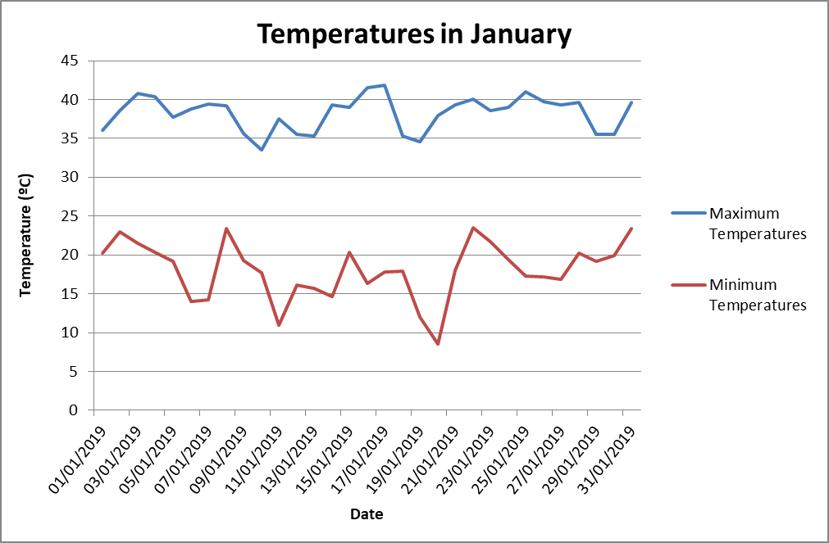
- Her habituation is not great but dispersal is working on her by visiting and trying to get her interested in egg and get her to jump on the scales.

Gold Diggers:
- Two pregnant females were seen at Gold Diggers in January, and another female was pregnant but lost her litter as the group moved to a different sleeping burrow after she had given birth.
- Habituation is slowly improving with the group getting more comfortable with volunteers gradually reducing the distance with the sleeping burrow, more individuals are approaching to eat egg, and they are not running away as much as they used to when leaving the burrow anymore.
- All members are in good health.

Hakuna Matata:
- Subordinate female Flint Lockwood (VHMF001) has given birth but lost her litter, she did not lactate and the group never left individuals to babysit.
- Dante (VHMM007) went roving three times this month, approached Ubuntu once and Lazuli twice but always came back to his home group. Guacamole (VHMM008) also went roving twice.
- Hakuna Matata had two group encounters with Lazuli, and retreated on both occasions.
- All members are in good health.

Jaxx:
- Dominant female Baloo (VJXF080) is officially pregnant again.
- Kanye (VCRM002) has been seen approaching Jaxx three times this month.
- Small pup Muscat (VJXF123), one of the two females in Baloo’s latest litter, went missing and received her last seen date, but the five remaining pups are successfully foraging with the group.
- All members are in good health.

Lazuli:
- Subordinate females Sigma (VLF230) and Tonks (VLF235) both lost their litters, but Sigma was evicted from the group. She tried to rejoin once, unsuccessfully and is yet to return.
- Males Papangue (VLM224), Schwanli (VLM237) and Baerli (VLM238) are still absent from the group. Rubeus (VLM236) returned for one day but left again and is yet to rejoin.
- Jabok Black (VJXM098) went roving 4 times and Finnick (VLM234) twice but both returned successfully.
- Younger males Thursday (VLM239) and Fledermaus (VLM242) left the group at the end of the month and are yet to return.
- The group had two encounters each with Ubuntu and Hakuna Matata.
- They had one encounter with Ubuntu males Bon-Bon (VUBM016) and Shrew (VUBM018), and two with Hakuna Matata male Dante (VHMM007).
- The group are all in good health.

Make-e-plan:
- Dominant female Bridget’s (VQLF011) litter emerged successfully with 3 pups being seen. Unfortunately 2 were lost quite early on, with one still remaining and foraging well at the end of the month.
- Subordinate females Bearnaise (VMPF004), and Dauphinoise (VMPF007) were made pregnant, gave birth but lost their litters. Also sub-adult females Moo (VMPF019) and Toscana (VMPF020) were also made pregnant but aborted their litters.
- Van Helsing male KevKev (VVHM112) was seen away from the group, looking very sick from TB and has yet to return.
- The group had two encounters with Van Helsing, at the beginning of the month.
- Sadly dominant male Le Grand Obstacle (VVHM103) was looking skinny and fatigued at the end of the month. All other members are looking healthy.

Namaqua:
- Dominant female Heatherleigh (VQLF018) and subordinate female Megatron II (VMPF001) both gave birth this month and the group is babysitting well.
- All members are looking a bit skinny.

Run Amuk:
- Dominant female Bean (VRUF001) sadly aborted her litter early in the month
- Subordinate male Reepicheep (VHMM003) is still missing.
- Little Creatures male Kanye (VCRM002) went roving from the group twice, being seen at Jaxx. He returned to his natal group Little Creatures so was emigrated back out of Run Amuk
- All members look healthy

Ubuntu:
- Subordinate females Minusch (VBBF109) and Etosha (VUBF005) gave birth but lost their litters quickly. Younger female Rick & Morty (VUBF013) also aborted her litter.
- Sub-adult female Meticulous Brown (VUBF019) is also pregnant.
- Yearling male Mr Bojangles (VUBM015) and female Etosha (VUBF005) both left the group but returned successfully.
- Yearling males Bon-Bon (VUBM016) and Shrew (VUBM018) went roving at the end of the month and are yet to return.
- The group had an encounter with Hakuna Matata male Dante (VHMM007).
- The group encountered Lazuli twice this month and Zulus once.
- Habituation is still improving with Etosha (VUBF005) now approaching volunteers and getting into the scales. A wild male is still being seen on and off with the group and his habituation is going steady.
- All members are in good health

Unknown:
- Lone female Logi (VBBF104) unfortunately gave birth and lost her litter.
- She still looks very healthy.

Van Helsing:
- Dominant female Inara (VVHF109) gave birth this month and the group are babysitting well. Subordinate female Kaylee (VVHF110) is still pregnant.
- Sadly, Fathom (VVHM114) was euthanised this month due to suffering badly from TB.
- Tim Tam (VVHF127) and Memphis (VVHM128) each left the group once but successfully returned.
- The group had two encounters with Make-e-plan and one with a wild group.
- The group had two daily group splits, returning successfully.
- Subordinate male Hobo Llama (VVHM123) and sub-adult female Glen-Coco (VVHF126) are both unfortunately showing signs of TB.
- The rest of the group are yet to show signs of TB and seem to be healthy.

Whiskers:
- Unfortunately, one pup (VWF220) from Swift’s (VWF176) latest litter was lost after their first forage with the group, but all the other 4 pups are foraging well.
- BUT Dominant female Swift (VWF176) was made officially pregnant again at the end of the month.
- Roving male Hey-Hey (VWM207) was given his last seen date this month.
- Cleo (VWM205) went roving once this month but returned on the same day.
- The group had one daily group split.
- All members look healthy.

X-Force:
- Unfortunately, dominant female King Eric (VVHF115) aborted her litter at the beginning of the month and subordinates Molly-Moo (VVHF113) and Murray (VVHF116) lost theirs near the end of the month.
- Ubuntu male, Esbardo (VUBM006) is now officially the dominant male.
- Ubuntu male Tino (VUBM002) is still missing.
- The wild males are still seen with the group on and off.
- Unfortunately dominant female King Eric (VVHF115) has a TB lump showing on her neck, but all other members are looking healthy.

Zulus:
- Dominant female Poma’s (VZUF007) litter successfully emerged, with 3 male pups being added to the group. Unfortunately all 3 were lost assumed to be predated.
- The group had 2 encounters with an Unknown male this month and one encounter with Ubuntu which they retreated from.
- The group had their first group split in 3 years, but all returned successfully.
- Subordinate male Special Sauce (VZUM026) went roving again this month. He left the group for the third time at the end of the month and has yet to rejoin
- Dominant female Poma (VZUF007) is looking a bit skinny after giving birth but is looking healthier. The rest of the group are healthy.

The following authors contributed to this report:
Lorna Harvey, Life History Volunteer

Lucie Reinwalt, Life History Trainee

Group Territories January 2019
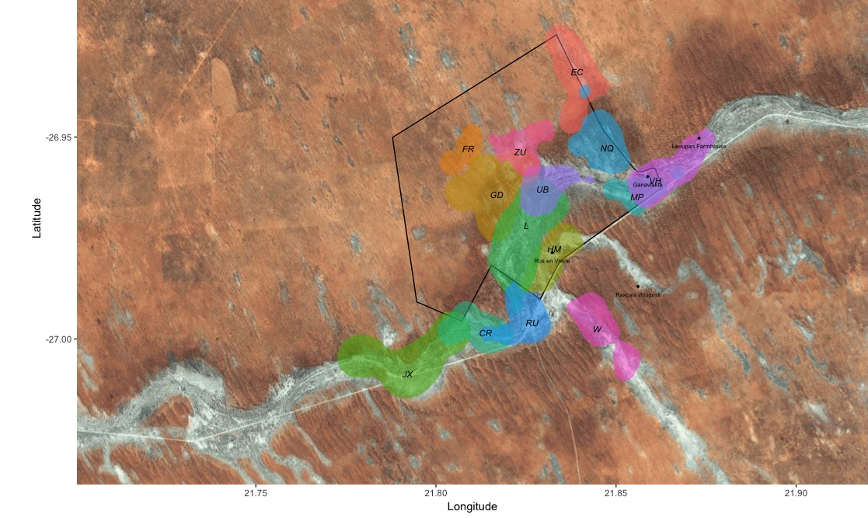

Key: CR: Little Creatures, EC: Elrond’s Council, FR: Freetails, GD: Gold Diggers, HM: Hakuna Matata, JX: Jaxx, L: Lazuli, MP: Make-e-plan, NQ: Namaqua, RU: Run Amuk, UB: Ubuntu, VH: Van Helsing, W: Whiskers, ZU: Zulus. ** X-Force is not on the territories map this month as they have moved quite far away from the reserve.

