 The Meerkatter

The Friends of the Kalahari Meerkat Project Report – www.kalahari-meerkats.com – July 2019
The Whiskers boys are on the rove again..…………..……... | 1-2 |  | Weather at the KMP…………………………...……………. | 3
Dominance turnover………………….……………..…………. | 2-3 |  | Life History Details……………………………...……………. | 3-4
Pregnancies in July…...……………………………………….. | 3 |  | Group Territories July 2019…………………...…...….……. | 5

The Whiskers boys are on the rove again

Van Helsing were having a calm month of July; the juveniles were growing up and the five wild males were getting better and better habituation wise.
They had mostly been found by the Leeu Pan farmhouse, in a neighboring reserve, at about 2 kilometers from the KRR. By the end of the month, they had moved down towards our reserve, and towards Namaqua’s territory.

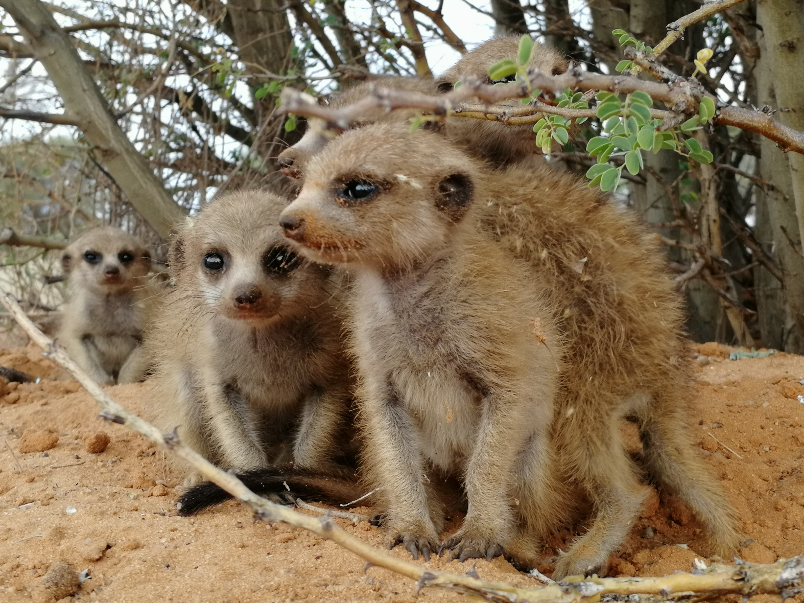
All five pups at Namaqua resting under a shrub while the adults ere foraging and running to them to feed them. Four adults was already a small number to take care of five pups, but the group being down to two adults, they are putting more energy into pup care and are this might be detrimental to the dominant pair over time. Photo Credit: Meerkat volunteer Lucie Reinwalt.

On the 29th of July, Narelle Hill, one of the Meerkat volunteers, was following Van Helsing for a morning session. The group alarmed, separated and the five wild males ran away. After a few minutes, the group was found again, but without those males. Instead, another individual, habituated this time, was found to already be acting as part of the group. It turns out, Namaqua had gotten up at a sleeping burrow 200 meters away from the one Van Helsing had spent the night at, and Bonnie (VWM209) had crossed paths with Van Helsing! By the time the group was being followed again, after the alarm and the separation, Bonnie (VWM209) had managed to make himself a member of Van Helsing. The five wild males were gone, and probably did not approach the group again as an unknown individual was with the group.
Bonnie (VWM209) had not been seen receiving any aggression from the six remaining members of Van Helsing, on the contrary, he was asserting his dominance on all the other members, and some would even submit to him in such a short amount of time.
But this unusual morning had another surprise for the group, encounters with another individual. With Namaqua very close by, and Bonnie (VWM209) with Van Helsing, the rover was obviously Clyde (VWM208), the other now famous Whiskers adventurer. He tried to approach the group a couple of times but was not successful, he got chased away and retreated. He was not seen again in the afternoon, and was thought to be back to Namaqua, his latest group.
On the next day, the 30th of July, Bonnie (VM209) was still at Van Helsing, and Clyde (VM208) was still roving around the group. As no volunteers were send to Namaqua on those two days, we would not know if Clyde (VWM208) was back at his group overnight or not. But later on this same day, Van Helsing stopped chasing the lonely rover and accepted him. The five wild males were not back, but Van Helsing had gained a new male member.

As a quick reminder, three males from Whiskers left their home group last summer, Cleo (VWM205), Bonnie (VWM209) and Clyde (VWM208). After having crossed the entire reserve, they found the newly formed (at the time) Namaqua and immigrated in. The three males fought and competed for dominance for a very long time with the former dominant Lewie (VLM228) that ended up winning his dominant position. Cleo (VWM205) disappeared, leaving the two other Whiskers males with Lewie (VLM228), Heatherleigh (VQLF011) the dominant female; and five very healthy pups before they both decided to go on another adventure.

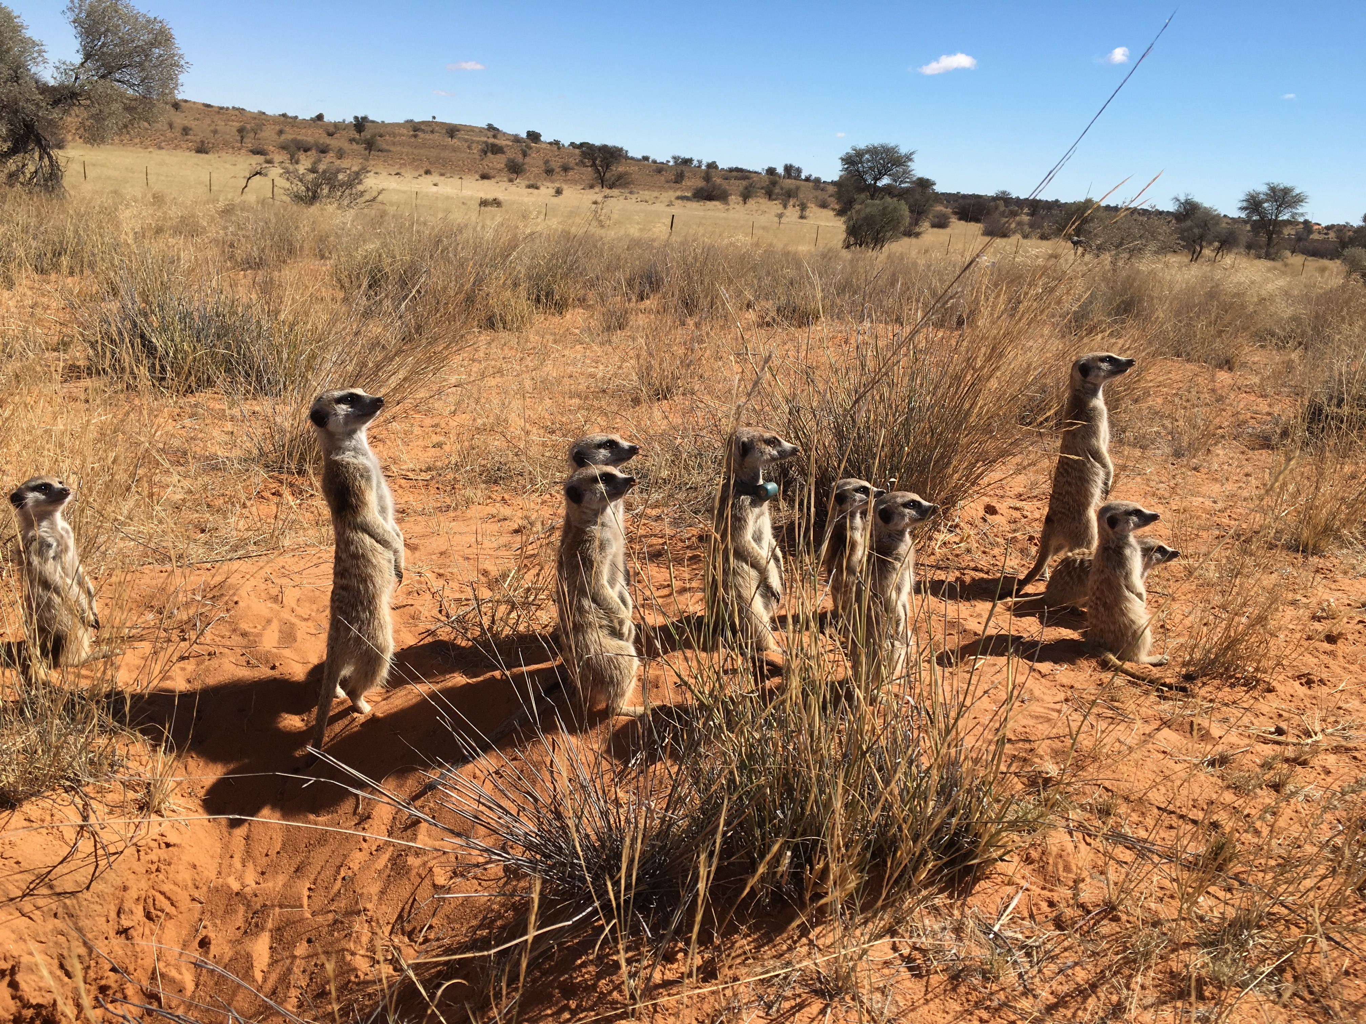
Whiskers, when Bonnie (VWM209) and Clyde (VWM208) were still a part of the group, before they left to go roving. Photo Credit: Former Meerkat volunteer Lorna Harvey.

At the end of July, Van Helsing was counting Tim Tam (VVHF127) the dominant female, Quincy (VVHF129) her litter mate and yearling subordinate female, the four juveniles and the two Whiskers rovers Bonnie (VWM209) and Clyde (VWM208) that were competing between the two of them for male dominance, none of them seem to have won so far. August will tell us if they have decided to settle down at Van Helsing, if they will go back to Van Helsing or if they will simply going to go roving again and visit other groups.

This story illustrates the end of the winter season, and the early start of the breeding season as more and more males are starting to leave their groups temporarily to go roving and are trying to find mating opportunities. It is indeed still very early in the year, but temperatures are getting warmer already and nights are not that cold anymore. A few females are also pregnant again, winter does not stop litters to be born but they are rarer. By the end of July, three females got pregnant, at about the same time, another sign of a change in seasons! The remaining question being: will the change in temperatures keep going or will they drop again to a colder August?

Dominance turnover

Our next story also involves a member of Van Helsing, but at a different group. Shamal (VVHM111) had been the dominant male at Make-E-Plan for about six months. He took over dominance after his brother Kevkev (VVHM112) had passed from being too sick from TB. Sadly, even though Shamal (VVHM111) seemed to be fine when he became dominant, he became very sick from TB as well. He was still asserting his dominance over other Make-E-Plan members, and no competition for his hierarchical position had been reported, until the 5th of July. On this day, Shamal’s (VVHM111) younger brother Banksia (VVHM117) was seen asserting dominance over Shamal (VVHM111) that would submit to him. No competition or fight were seen, the dominance change appeared to have happened very quickly and with no actual opponent for Banksia (VVHM117) that probably took advantage of the weakness of his older brother getting sicker and sicker. From this day on, Banksia (VVHM117) is acting dominant and no other individual has been seen trying to compete with him.
Shamal (VVHM111) got too sick and had to be euthanized for his own welfare.

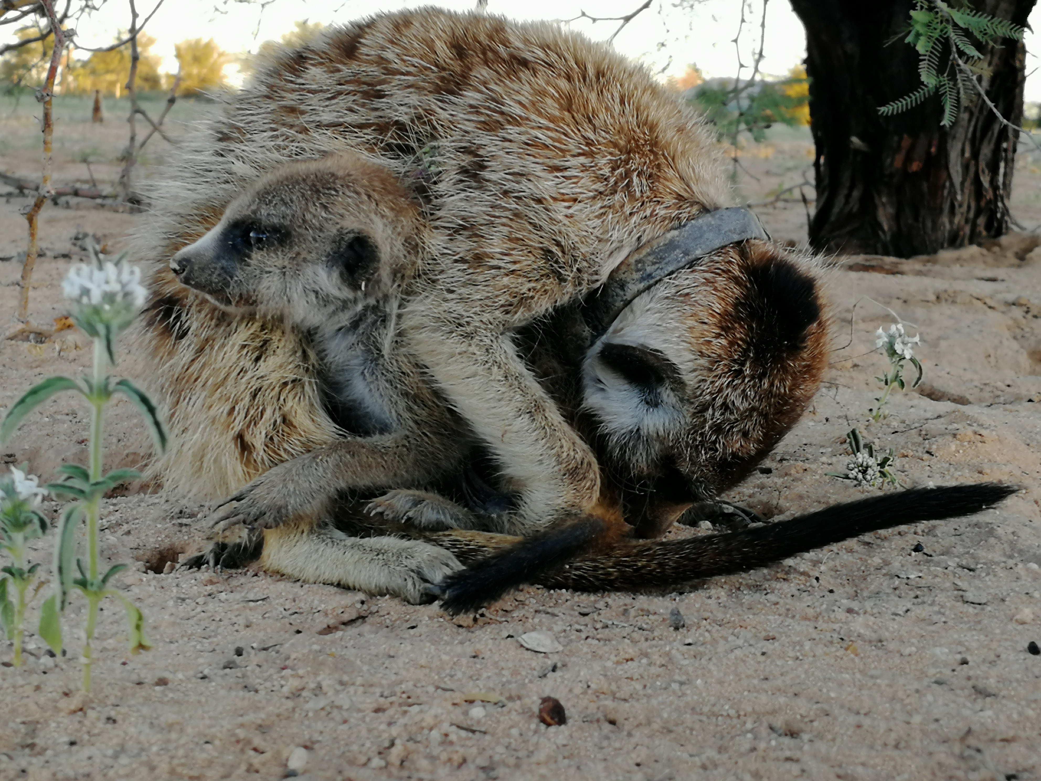
Shamal (VVHM111) hugging a little pup to keep him warm at the sleeping burrow once they had returned in the evening. Photo Credit: Meerkat volunteer Lucie Reinwalt.

Banksia (VVHM117) is now the third dominant male being born into Van Helsing. This is no coincidence, as almost a year ago now, four males from Van Helsing left their home group and immigrated into Make-E-Plan. The group does not seem to be perturbed by these changes in dominance, Bridget (VQLF018) still leads the group with all the character we know her. She likes asserting her dominance on all the other members of her group, but is also a very carrying mother. Her most recent litter was born in June, and two males from this winter litter are still with the group. Three pups were first seen, but they were all so small when they emerged that having brought two to this age is very impressive. Luckily, even though quite a few males from Van Helsing were at Make-E-Plan and had shown TB symptoms, the rest of the group (the dominant female and all the Make-E-Plan born individuals) are looking more than healthy and nothing has ever given volunteers to think that another individual might have TB.

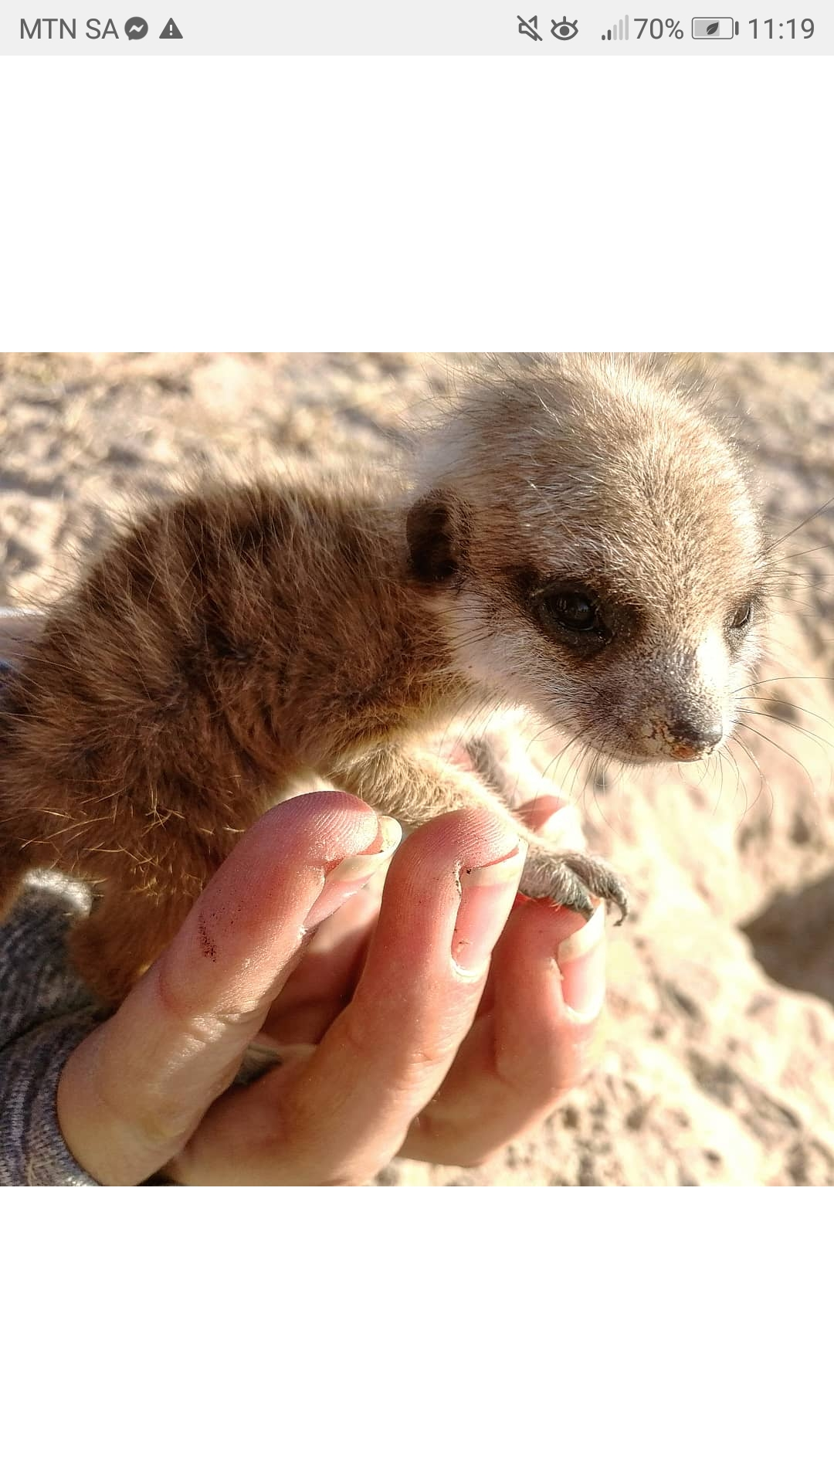
One of the very small pups at Make-E-Plan the day after they had emerged for the first time. They were all weighing less than 50grams! Photo Credit/ Meerkat Volunteer Lucie Reinwalt.

Pregnancies in July 2019

Females pregnant in July | 4
Females who aborted | 0
Females who gave birth, litters lost | 0
Females who gave birth, litter emerged | 1
Females who gave birth, unknown outcome | 0
Females still pregnant at the end of the month | 3

Weather at the KMP
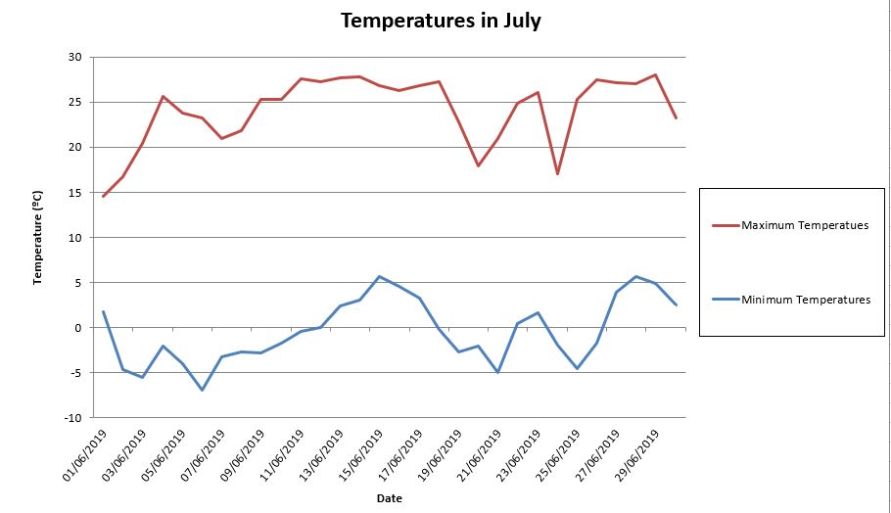
July started off with cold nights, with a minimum of -6.9°C but days got much warmer with a maximum of 28.0°C. As a usual winter month, no rain has fallen on the Kuruman River Reserve in July.

July 2019 Life History Details

(Little) Creatures:
- LL Cool J (VLM207) has not returned in July, he therefore got his last seen date, and Little Creatures is down to eight members.
- Habituation is improving, but the two adult females and the yearling male have not been getting up with the group very often or would just wake up and leave the burrow, which makes it difficult for habituation.
- All members are in good health.

Elrond’s Council:
- Volunteers have kept going with normal habituation sessions in the morning and burrow sits in the evening. Elrond’s Council are improving greatly, as they are used to having us around in the evening now and are starting to be comfortable with volunteers approaching when they are returned. They will probably be good enough to be followed very soon!
- The group is in good health.

Gold Diggers:
- Volunteers thought to have lost Gold Diggers in July, as for two days, they were able to track the radio collar at the same sleeping burrow, but no meerkat had been seen and no fresh tracks were spotted around the burrow. Thinking something could have had happened to Scaramouche (VGDM004), volunteers were started to get sad and worried. But on the third day, the radio collar lead to a different sleeping burrow and all the group got up with Scaramouche (VGDM004).
- All members are in good health.

Hakuna Matata:
- Flint Lockwood (VHMF001) gave birth early July, and four pups emerged for the first time on the 31st!
- Double Fluff (VHMF010) appeared around Hakuna Matata five times before returning to the group the day after Flint Lockwood (VHMF001) gave birth, they are now both lactating and the group is still babysitting.
- Warmer days have come back, and so have rovers, Pet (VCVM001), Dante (VHMM007) and Guacamole (VHMM008) have left their group together and were away for two days. They have approached Ubuntu multiple times but got chased away.
- Another male decided to go roving in July, Fledermaus (VLM242), with whom Hakuna Matata had an encounter with.
- Double Fluff (VHMF010) has scabs on her tail and on her nose, from Mozarella (VHMF015) being aggressive to her. All other members are in good health.

Jaxx:
- Baloo (VJXF080) is officially pregnant once more.
- Rollie (VJXM101) went on a short adventure, he left and returned on the same day.
- All members are in good health.

Lazuli:
- Sigma (VLF230) is officially pregnant for the first time since she became the dominant female.
- Fledermaus left, approached Hakuna Matata and returned to his home group on the same day.
- Lazuli has encountered an unknown meerkat twice in July.
- The group are all in good health.

Make-e-plan:
- Banksia (VVHM117) took dominance over Shamal (VVHM111) on the 5th of July, Banksia (VVHM117) was asserting his newly gained dominance on his older brother that became very submissive.
- Shamal (VVHM111) being too sick from TB after a rapid decline, he had to be euthanised shortly after the dominance change.
- One of the three smaller pups (VMPP033) disappeared during a day of foraging and has not been seen since.
- The group has encountered two unknown meerkats twice this past month, and had an overnight group split once.
- The group members are all looking healthy.

Namaqua:
- Quarrel (VNQM010), one of the juveniles, has lived an interesting episode in July. The group returned, and Quarrel (VNQM010) was the last one up. When he realised no one else was around, he panicked and ran away, he did not go below with his family. The next morning, he was seen up in a distance, but was not coming back to the sleeping burrow. When the group got up, Lewie (VLM228) heard lost calls and ran off. A few minutes later, he came back with Quarrel, and all the Namaqua family was reunited!
- At the end of July, Van Helsing was close to Namaqua. Bonnie (VWM209) and Clyde (VWM208) took this as an opportunity, and left Namaqua to immigrate in Van Helsing where they were accepted! The group is therefore now down to seven individuals.
- All members seem to be in good health.

Tswana:
- Four small pups emerged and started to forage with the group in July, but sadly one of them did not wake up with the group one morning and has not been seen since.
- Habituation is still progressing very fast, volunteers are now able to be standing and moving at 25 meters and were able to approach at 7 meters as the pups are very curious.
- The group looks healthy.

Ubuntu:
- Once again in July, males have left their home groups to explore the surroundings. Bon Bon (VUBM016) left and returned once, just like Scar (VUBM021). Shrew (VUBM018) went on three different adventures, he indeed left and returned three times in July.
- Ubuntu had a few visitors, Pet (VCVM001), Dante (VHMM007) and Guacamole (VHMM008) approached the group and insisted on staying around before being chased away.
- The habituation at Ubuntu can now be considered as full, and even though some individuals are still easier than others to get close to, this is just like in all the groups.
- All members are in good health.

Van Helsing:
- Van Helsing has experienced a lot of movements in July. The group has split four times in total, three of them were daily group split but on was an overnight one where the dominant female was found by herself in the morning before rejoining with the rest of the group.
- Azote (VVHF133) left for a short amount of time before returning. The recently dyed dominant male (VVHM136) left three times, and only returned twice, he is indeed absent at the end of the month, and so are the four other wild males as they all left together.
- The reason why those males have left Van Helsing is that two other males immigrated in. Van Helsing and Namaqua were using sleeping burrows that were very close to each other, and our two famous rovers Bonnie (VWM209) and Clyde (VWM208) approached Van Helsing, were accepted and immigrated in! The two new members of Van Helsing are still competing for dominance.
- The two yearling females, Tim Tam (VVHF127) and Quincy (VVHF129) are still presenting TB symptoms and do not seem to get better.
- The juveniles seem to be healthy, and so are the two new males.

Whiskers:
- Swift (VWF176) is, once again, officially pregnant.
- We left June with three pups, sadly only one pup, Mercy (VWF230), made it to the end on July.
- All members look healthy.

Zulus:
- Sauce (VZUM026) returned on the first of July, but went roving again four more times in June, leading Palestrina (VLM211) with him twice.
- The group is looking healthy.

The following authors contributed to this report:

Lucie Reinwalt, Life History

Group Territories July 2019
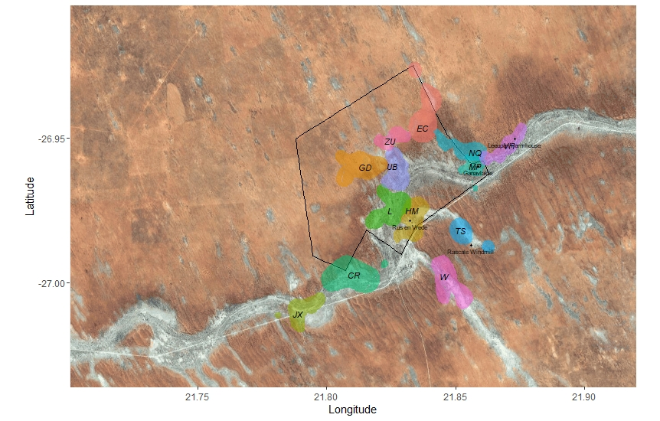

Key: CR: Little Creatures, EC: Elrond’s Council, GD: Gold Diggers, HM: Hakuna Matata, JX: Jaxx, L: Lazuli, MP: Make-e-plan, NQ: Namaqua, UB: Ubuntu, TS: Tswana, VH: Van Helsing, W: Whiskers, ZU: Zulus.

