The Meerkatter

The Friends of the Kalahari Meerkat Project Report – www.kalahari-meerkats.com – March 2019
King Lewie overthrows the Whiskers invaders………………. | 1-2 |  | Weather at the KMP……………….……….………………… | 3
Threats coming from below……………………………………. | 2-3 |  | Life History Details …………………………………………… | 3-4
Pregnancies in March………………………………………… | 3 |  | Group Territories March 2019 | 5

King Lewie overthrows the Whiskers invaders

The storm of events that hit Namaqua last month did not calm down in March, but tricked Heatherleigh (VQLF018), Lewie (VLM228), Cleo (VWM205), Clyde (VWM208) and Bonnie (VWM209) by giving them a short break at the end of February before striking again. As a reminder, three roving males from Whiskers immigrated in the group, leading to the loss of the recently emerged litters, Lewie (VLM228) to lose dominance and Chateaubriand (VMPM005) the subordinate male to leave the group. Megatron II (VMPF001) had last been seen just before the new members approached Namaqua.

Early March, Cleo (VWM205) and Clyde (VWM208) were competing for dominance, joined by Bonnie (VWM209) later on. The former dominant male Lewie (VLM228) did not take part in the competition and was acting like a subordinate male watching from a distance.
Another chaotic day for our five already busy meerkats, as Make-E-Plan interrupted the daily competitions with an hour long intergroup interaction. The enemy being a significantly bigger group they had encountered before, Namaqua retreated. But as the face off kept going, all four males left one after the other, leaving the dominant females behind and by herself. They came back to her later this day.
After this eventful morning, the three Whiskers males kept going with dominance competitions, with Cleo (VWM205) showing signs of dominance as he was marking the territory a lot but Bonnie (VWM209) and Clyde (VWM208) were competing the most intensively.

On the 14th of this month, Bonnie (VWM209) was not seen on arrival by the volunteer assigned to the group in the afternoon. He returned later during the session, was shivering, limping, had a large cut going from his mouth to left ear, his left eye shut and this region very swollen. Volunteers think he got into a fight with Clyde (VWM208) and lost, being out of the picture for the male dominance. Cleo (VWM205) and Clyde (VWM208) were then competing very intensively, when Bonnie (VWM209) submitted to all the other males in the group, could not even forage and became skinnier, fatigued but was slowly healing. He did get better as he was still very submissive to the two competitors.
Then, out of nowhere, volunteers were more than surprised to witness Lewie (VLM228) the once dominant male that had not taken part in competitions, joining the fight. The number of competitions recorded reached numbers current volunteers had never seen, Cleo (VWM205), Clyde (VWM208) and Lewie (VLM228) engaging all their energy into very intense fights and competitions. All males got out of it severely injured. Cleo (VWM205) had a swollen, cut and limping left forearm and a cut under his left eye. Clyde (VWM208) was bleeding from the ride side of his neck and had his right forearm and face swollen. Lewie (VLM228) was also covered in blood, was limping and had a swollen face. Clyde (VWM208) was in a very bad shape, crawled down on the ground with Bonnie (VWM209) that did not even fight on this day. Cleo (VWM205) and Lewie (VLM228) kept fighting, until dominance competition stopped on the 24th of March.

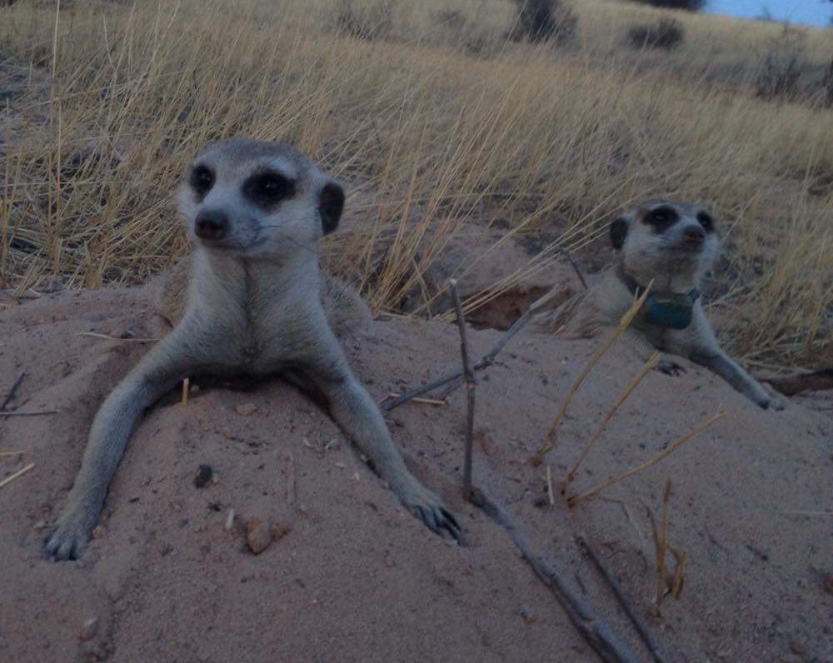

The former and new dominant pair at Namaqua: Heatherleigh (VQLF018) on the right and Lewie (VLM228) on the left. Photo Credit: Former Dispersal and KMP volunteer Tash Harrison.

From this day on, volunteers have seen Lewie (VLM228) asserting his newly regained dominance on all the other members of the group, and have seen the three Whiskers males submitting to him. Namaqua had a dominant male again after a month of competitions, but it was a surprise to all to see the former dominant male winning his hierarchical position again. The end of the month looks brighter than the start of it, with all injuries healing fast, and Heatherleigh (VQLF018) the dominant female being pregnant. We can only hope for a successful litter to this group, seeming to finally have found a balance between all its members cohabiting together.

Threats coming from below

Odds were in favor of pup survival in March, February had given us rain and a lot of pregnant females, the Kalahari was looking green, meerkats were finding a lot of food and were all looking healthy.

Swift (VWF176), the dominant female at famous Whiskers, was very pregnant and gave birth overnight between the 6th and the 7th of March. Meerkat volunteer Celine Bocquet visited the group on the 7th in the morning, and could see that Swift (VWF176) had started to lactate. Once the group was up and sunning at the sleeping burrow, they started to alarm at a still unknown threat, ran back below and came back up carrying three newborn pups above ground. One pup was left at the sleeping burrow, on the ground; the two other pups were carried away. Adults were running from the sleeping burrow they woke up at, and dropped a pup on their way. They did not turn back and kept going as Swift (VWF176) was leading them carrying the last of her pups, probably trying to escape a threat they encountered below ground. The group stopped running once they had reached a bolt hole where they brought the pup at, more than 700 meters away from the start of their race. This is where they started to forage, staying around the bolt hole, having at least one older individual at a time watching over the tiny newborn.

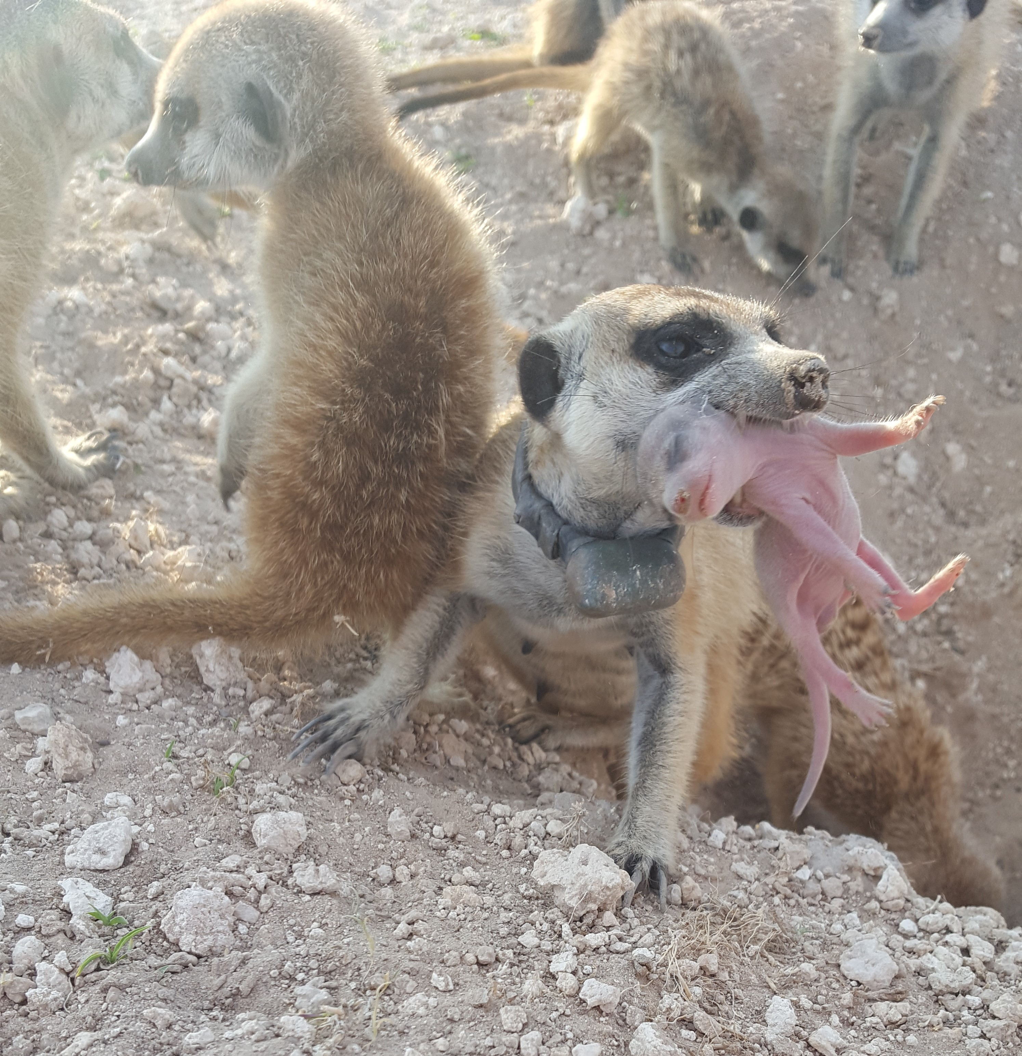
Swift (VWF176) the dominant female at Whiskers carrying one of her newly born pups out of the sleeping burrow to a safer shelter. Photo Credit: KMP volunteer, Celine Bocquet.

The pup being less than 24 hours old, volunteers were not expecting it to survive. In the afternoon, the group was found at the same bolt hole they were left at in the morning, the pup still being babysat from this unusual shelter. The day coming to an end, the group carried this pup one more time but on a much shorter distance. Swift (VWF176) took her pup below at a sleeping burrow 100 meters away, and spent the night there. The next day, no babysitter was left at the burrow, the pup was reported as being left on its own, and the dominant female (VWF176) did not seem to be lactating anymore. Over the next few days, some individuals were not seen at all, assumed to be babysitting, they had used the same sleeping burrow, even though lactations were not clear. On the 10th, Bones (VWF212) started to lactate and so did Swift (VWF176) the next day. The pup was left on its own very often, and would be babysat from time to time. Volunteers were still unsure about the outcome, but on the 20th, a pup had been seen. A week later, one single healthy looking pup emerged and started to forage with the group. Swift (VWF176) and Bones (VWF212) are still both lactating, and every member of the group is trying to feed the pup when it is out with them. The happy ending was a surprise to everyone at the KMP!

Many females gave birth in March, one of them was Poma (VZUF007) the dominant female at Zulus. Her last successful litter being almost a year old, volunteers were very excited about having new pups at this group everyone loves. Poma gave birth on the 13th of March, started to lactate, and the group babysat the newly born members of their family. On the 18th, four pink furless pups have been seen being carried out of the babysitting burrow to the surface, the adults running with the pups in their mouths. The rest of the group started to forage, with the pups being taken care of on the surface, they were being groomed and babysat. Poma (VZUF007) was not looking great; she had multiple bloody lacerations on her left arm, a 2 centimeter open wound on her neck, her face was swollen and her left eye shut due to the swelling, and was also fatigued. The group probably kept the pups above ground because of a threat they encountered in their babysitting burrow, and might have been too scared to take them back below. Zulus eventually carried the pups to a different sleeping burrow, far away from danger.

The next morning, Poma (VZUF007) was found to be dead, volunteers at the KMP were all sad to see one of the most iconic meerkats disappearing. Her injuries are thought to have come from snake bites, the group had probably found a snake in their sleeping burrow and decided to move the pups, Poma (VZUF007) going against the predator to defend her litter.
No other female started to lactate, but the group kept on babysitting for a few sessions before moving to a different sleeping burrow. From this moment on, no babysitter was left behind and no female was lactating, the group had lost their litter.
As Zulus is left with no dominant female, Spruddel (VZUF028), Lil’ G (VZUF029) and Lentil (VZUF032), the three subordinates, started to compete for dominance.

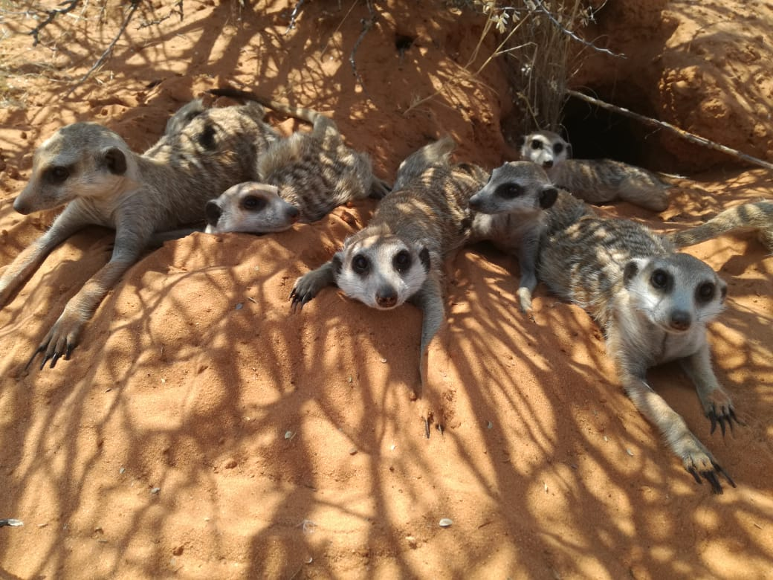
Zulus resting at a bolt hole. Photo Credit: Former KMP volunteer, Angelique Lazarus.

These two stories demonstrate how groups, and especially dominant females, put themselves in grave danger to try to protect and save their litters. We can only wish a brighter and calmer month of April for Whiskers and Zulus.

Pregnancies in March 2019

Females pregnant in March | 18
Females who aborted | 0
Females who gave birth, litters lost | 2
Females who gave birth, litter emerged | 2
Females who gave birth, unknown outcome | 5
Females still pregnant at the end of the month | 7
Females who are not pregnant anymore, unknown outcome | 2

Weather at the KMP

Temperatures in March are starting to fluctuate as we are slowly getting to winter. The maximum temperature reached this past month was 40.1°C, and the minimum was 10.4°C. The Kalahari did not get much rain, with only 4.2mm throughout the month.

March 2019 Life History Details

(Little) Creatures:
- Kanye (VCRM002) immigrated back in Little Creatures, and has stayed a faithful member of his home group for the rest of the month.
- Two pups have been seen from a distance by our volunteers.
- Habituation is improving; males are getting more and more comfortable with the scales, and their comfort distance is reducing.
- All members are in good health.

Elrond’s Council:
- Mouse (VECF001) had her last seen date in March and has therefore been removed from the group.
- Kamala (VBBF116) returned to Elrond’s Council and was accepted back by the group.
- Habituation is still improving, the wild dominant male is comfortable at a shorter distance and the group is getting used to the manipulation of equipment.
- The group looks very healthy.

Freetails:
- Dominant female Floob (VLF227) is still by herself.
- Dispersal has had troubles finding the lonely female in March, but is working on it by scanning the entire reserve hoping to find her again.

Gold Diggers:
- One adult female has given birth, two females are lactating and the group is babysitting.
- Habituation has been stable throughout March, the group is getting very good with movements.
- Volunteers are hoping to work on babysitters left at the sleeping burrow to push the habituation a little bit further
- All members are in good health.

Hakuna Matata:
- Alan Johnson’s Beamer’s (VLF206) litter has emerged; five healthy looking pups are now foraging with the group, and are very well habituated.
- Hakuna Matata had three intergroup interactions with Run Amuk this month, with the use of their territories overlapping.
- The group also had two daily group splits.
- Males seem to have settled down, has Dante (VHMM007) left and returned only once, and Guacamole (VHMM008) twice early March.
- All members are in good health.

Jaxx:
- The dominant female Baloo (VJXF080) is officially pregnant again, and so is Didah (VJXF112) the eldest subordinate female.
- Kanye (VCRM002) has approached Jaxx nine times this month, but the group did not react too intensively to the rover.
- All members are in good health.

Lazuli:
- Filthy McNasty (VLF223) gave birth in March.
- Tonks (VLF235) and Sigma (VLF230), the two evicted females, were accepted back in Lazuli and started to lactate for the newly born litter.
- The group encountered Ubuntu twice and had an encounter with Shrew (VUBM018) and with three unknown meerkats.
- The group are all in good health.

Make-e-plan:
- Dominant female Bridget (VQLF011) gave birth, the group is babysitting.
- Subordinate female Wispa (VMPF003) was officially pregnant and full term when she went below at night with the group, but did not wake up with the other individuals the next morning and has not been seen since.
- Crunchy Nut (VMPF006) and Dauphinoise (VMPF007) approached Make-e-Plan multiple times before being accepted back in the group, butBearnaise (VMPF004) is still missing.
- The group had three encounters with Van Helsing and two with Namaqua.
- The group members are all looking healthy.

Namaqua:
- After a month of competition for male dominance, Lewie (VLM228) won his throne back against the three males from Whiskers.
- Subordinate female Megatron II (VMPF001) and subordinate male Chateaubriand (VMPM005) are still missing, Megatron II (VMPF001) got her last seen date in March.
- Heatherleigh (VQLF018) the dominant and only female in the group is officially pregnant.
- All males are injured due to fights, but all of them are healing.

Run Amuk:
- Dominant female Bean (VRUF001) has given birth and started to lactate, the group is babysititng.
- Kanye (VCRM002) emigrated, immigrated and emigrated again out of Run Amuk early March, but has been sighted around this group since.
- Run Amuk had three encounters with Hakuna Matata, around their babysitting burrow.
- All members look healthy.

Ubuntu:
- Dominant female Daisy (VBBF111) gave birth and four pups have emerged.
- Eldest subordinate Minush (VBBF109) and subordinate Etosha (VUBF005) got their last seen date, has they have not been sighted for over a month.
- The group encountered Lazuli twice.
- Habituation is still progressing, Mr Bojangles (VUBM015) gets more and more comfortable in the scales box and Scar (VUBM021) accepts a shorter distance between volunteers and him.
- All members are in good health

Unknown:
- Logi (VBBF104) has not been found in March, volunteers are still looking around trying to find her.

Van Helsing:
- The four pups are successfully foraging with the group.
- Sadly, suffering from severe symptoms of TB, Glen Coco (VVHF126) and Moet (VVHF130) got euthanized.
- Inara (VVHF109), Memphis (VVHM128) and Hobo Llama (VVHM123) are showing symptoms of TB, they are skinny, fatigued and have TB lumps, volunteers are keeping a close eye on these individuals.
- The rest of the group seems to be healthy.

Whiskers:
- Dominant female Swift (VWF176) gave birth, one pup emerged.
- Bones (VWF212) is not pregnant anymore, but it is difficult to say if she has aborted or if she has given birth but lost her litter, as the group was babysitting and lactating for the dominant female’s litter.
- Saspa (VWF127) left the group late March.
- All members look healthy.

X-Force:
- Molly-Moo (VVHF113) took over dominance, King Eric (VVHF115) being now a subordinate in the group.
- Molly-Moo (VVHF113) and Murray (VVHF116) are officially pregnant.
- King Eric (VVHF115) still presents symptoms of TB, as her submandibular lump is getting bigger, but the other members of the group are looking healthy.

Zulus:
- Dominant female Poma (VZUF007) sadly died from her injuries after the group encountered a snake.
- The newly born litter has been lost, as no female was lactating, and the group moved burrows.
- Special Sauce (VZUM026) returned to Zulus early March and has not gone roving again in March.
- The remaining individuals are all looking healthy.

The following authors contributed to this report:
Lucie Reinwalt, Life History Volunteer

Group Territories March 2019
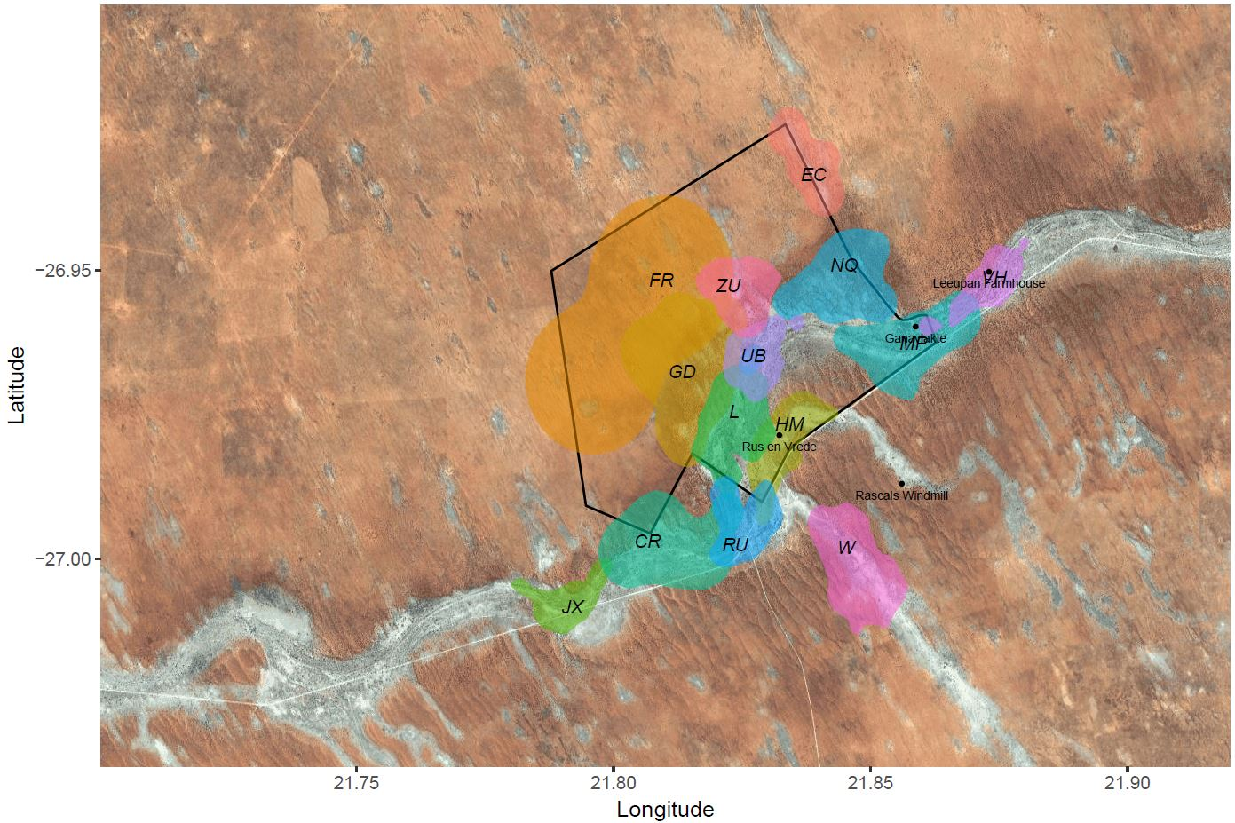

Key: CR: Little Creatures, EC: Elrond’s Council, FR: Freetails, GD: Gold Diggers, HM: Hakuna Matata, JX: Jaxx, L: Lazuli, MP: Make-e-plan, NQ: Namaqua, RU: Run Amuk, UB: Ubuntu, VH: Van Helsing, W: Whiskers, ZU: Zulus. ** X-Force is not on the territories map this month as they have moved quite far away from the reserve.

