The Meerkatter

The Friends of the Kalahari Meerkat Project Report – www.kalahari-meerkats.com – June 2019
The end of Van Helsing?.....…………………………..……... | 1-2 |  | Weather at the KMP……………………………………….. | 3
Get to know our habituation groups……………..…………. | 2-3 |  | Life History Details…………………………………………. | 3-5
Pregnancies in June………………………………………….. | 3 |  | Group Territories June 2019………………………….……. | 6

The end of Van Helsing?

June has not been an easy time for Van Helsing. For those who remember, the group was formed in 2008 by evicted females from Aztecs and wild males they had encountered. They used to be a very large group, reaching about thirty-five individuals. The group is nowadays suffering from tuberculosis, and is currently six meerkats strong, eleven including the five wild males that had immigrated into Van Helsing a few months ago.

Previously, at Van Helsing… Kaylee (VVHF110) had gained dominance when her sister Inara (VVHF109) split from the rest of the group, being too fatigued by TB to keep up. Inara (VVHF109) herself became dominant in November 2018 after Egg (VVHF042) the iconic former dominant had died, being very sick as well at the time.
If looking at dominant males, the last one the group had was Kucuk (VZUM017). He died in August 2018. No other male took over dominance since the tragic accident. In the meantime, many individuals have shown severe symptoms, and many have sadly not recovered, and Van Helsing got smaller and smaller.
In December 2018, Inara (VVHF109) and Kaylee (VVHF110) got pregnant at the same time, and gave birth one day apart. Four beautiful and healthy looking pups emerged and are still with the group at the end of June.
At the end of May, Tim Tam (VVHF127) and Quincy (VVHF129), just a year old, chasing the dominant female Kaylee (VVHF110) away from the group. The evicted female was seen around Van Helsing five times, but did not succeed in returning back into the group. Tim Tam (VVHF127) had won the competition for dominance over Quincy (VVHF129), as their older sister Kaylee (VVHF110) was still staying in the same area as her former group. Volunteers were going to check on her after sessions at the group, to report on her general condition and her location. She was last seen on the 20th of June, volunteers would be able to track her to the same sleeping burrow for several days in a row after this date, but she was not seen again and is therefore assumed not to have survived.

The five wild males have improved greatly in their habituation, one of them is even thought to have been a member of a habituated group before. The good wild male, has volunteers would refer to him, has become the dominant male and has been dyed for the first time in June, he is therefore now identifiable (VVHM136)! The other males are fine a few meters from volunteers and are till all faithful members of Van Helsing.

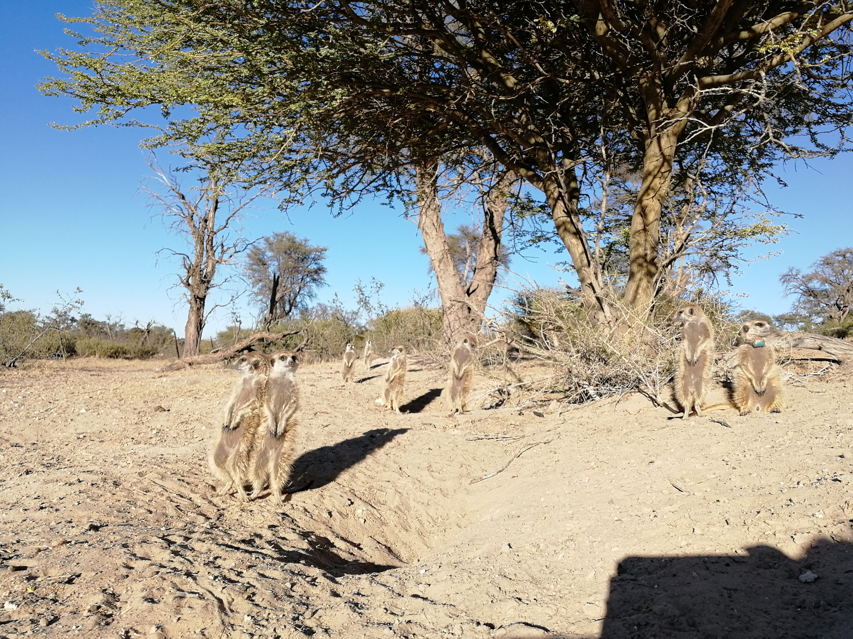
All six original Van Helsing members sunning with two of the five wild males further away. The three other ones were still below, but ended up emerging and sunned with all the other members of the group. Photo Credit: Meerkat volunteer Lucie Reinwalt.

The five wild males are looking healthy, even though exposed to TB on a daily basis. The four young members of the group seem to be healthy, but are recognized to be smaller than other meerkats of their age. Volunteers are hoping they will not contract TB symptoms and will get Van Helsing going as a healthier group soon.
On a sadder note, Tim Tam (VVHF127) and Quincy (VVHF129) are not doing great. They suffer from severe symptoms and do not seem to improve at the moment. Both present TB lumps, occasionally bursting, are both rather skinny and fatigued. The two yearlings might not survive the disease.

Volunteers at the KMP are very sad to witness the decline of Van Helsing, a group loved by all. One other Van Helsing born individual is still found in the population, Banksia (VVHM117), the newly dominant male at Make-E-Plan! He had dispersed and has joined his new group at the end of 2018. He is looking perfectly healthy, and brings hope to the Van Helsing legacy. Meerkat volunteers are obviously going to keep visiting Van Helsing, and are hopping for their well-being.

Get to know our habituation groups

The Kalahari has gotten colder, it is wintertime! Which means drama at our meerkat groups is calming down, less movements, less pups… Less activity. In these quieter days, something did strike meerkats volunteers, the progress our four habituation groups have made.

The oldest habituation group the KMP is working with is Gold Diggers, first collared in August 2017 and currently counting twenty one individuals. Despite all the energy and time volunteers have put into their habituation, progress is slow. It is indeed a large group (the largest of all groups the Meerkat Project keeps track of), which makes it more difficult to work on an individual level. Volunteers are able to sit at one to five meters, stand and move at five to ten meters. Very few of them are interested in egg, and group compositions are rarely fully possible to obtain as they are too many and are often behind shrubs or tall grass. But they are still improving, thanks to the perseverance of all the meerkat team. The main goal is now to reduce their comfort distance with us, even though weather conditions greatly affect habitation sessions, fun fact: Gold Diggers don’t like the wind!

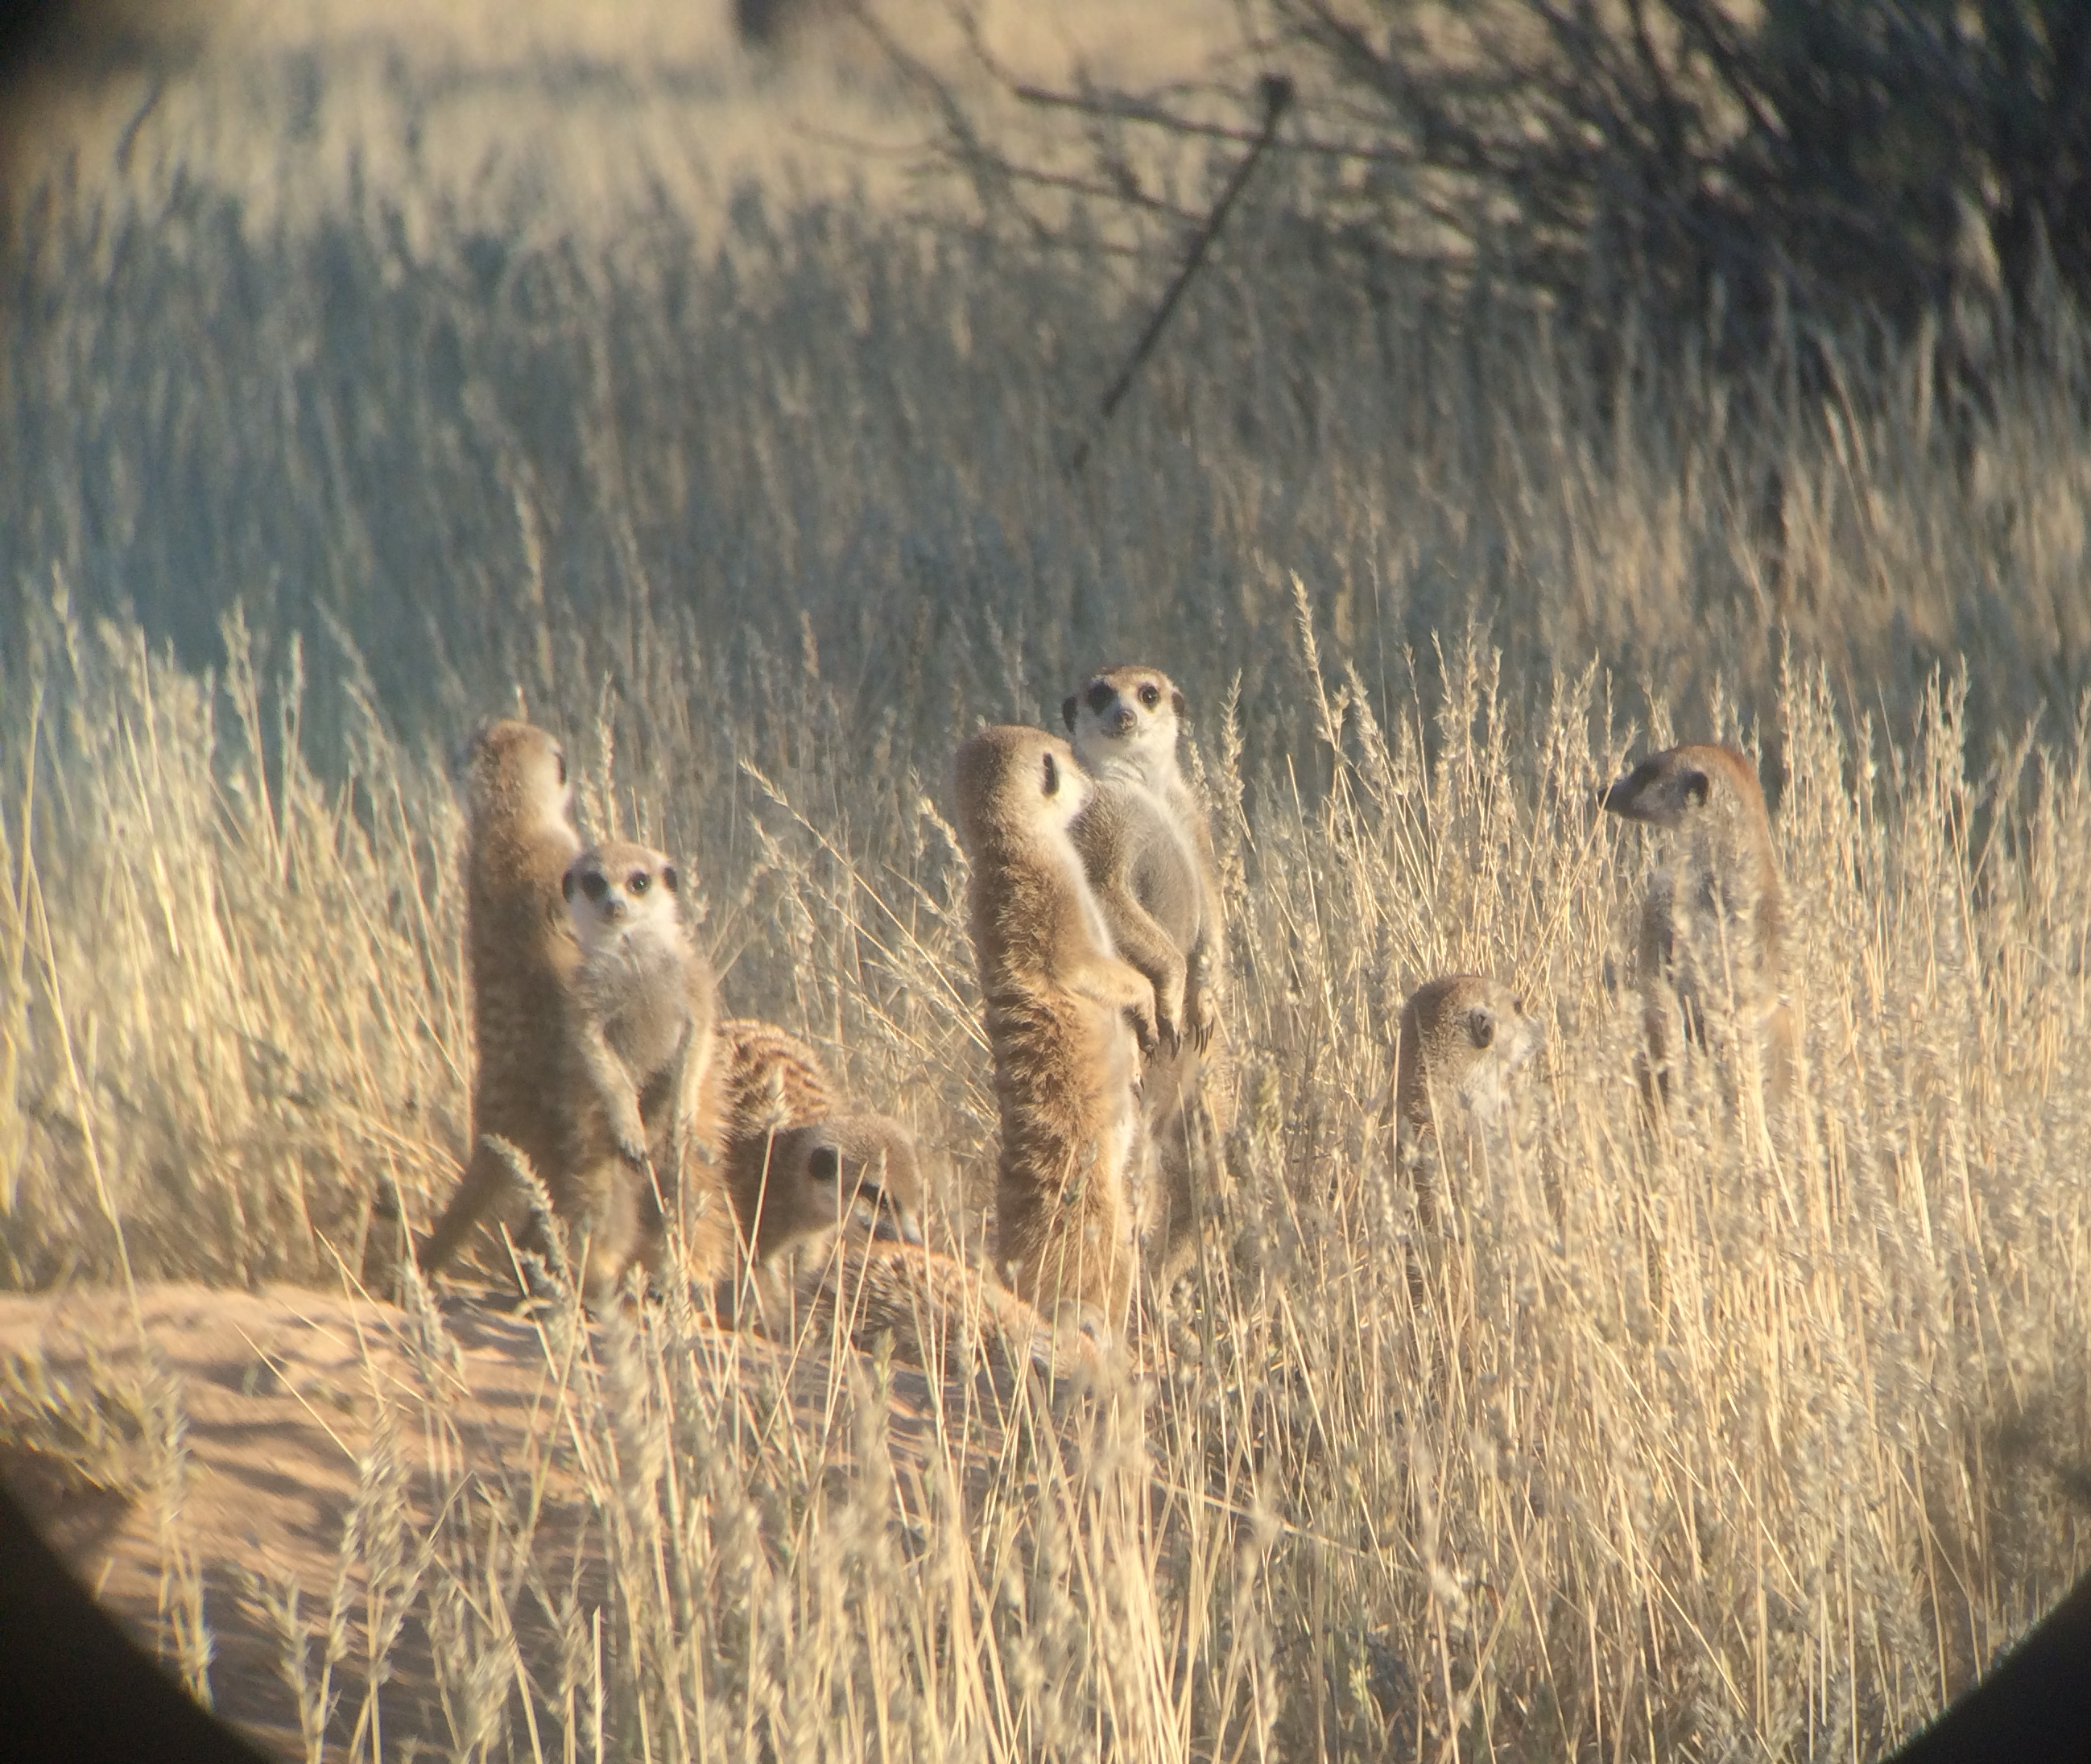
Gold Diggers sunning at a sleeping burrow, being observed by former Life history and Meerkat volunteer Lorna Harvey.

Elrond’s Council is the most advanced of the four habituation groups volunteers are visiting. The group was formed by evicted females from the habituated group Baobab in January 2018. Tayl Baez (VBBF117), that became dominant, and Kamala (VBBF116) were found with wild males, and are twelve individuals total today, eight of them being dyed. Even if all the individuals are not dyed, they are all easily identifiable by age, sex, or distinctive features. The two Baobab females, one yearling male and one yearling female, the sub-adult male and the three juveniles are all excellent, they are being weighed consistently and are comfortable with us walking around the group and moving just next to them. The dominant male, the other yearling female and the two last yearling males are a little bit more worried about volunteers, but this is very relative since they are still comfortable with movements at a few meters from them. The group had made such impressive progress, volunteers have now started to visit them in the afternoon as well! The goal is for them to be absolutely comfortable with having people at their sleeping burrow when they return at night, this is an important step in the habituation progress, and Elrond’s Council are all doing very well! Everyone is hoping for even more progress very soon, but no doubt they are not going to stop to surprise meerkat volunteers.

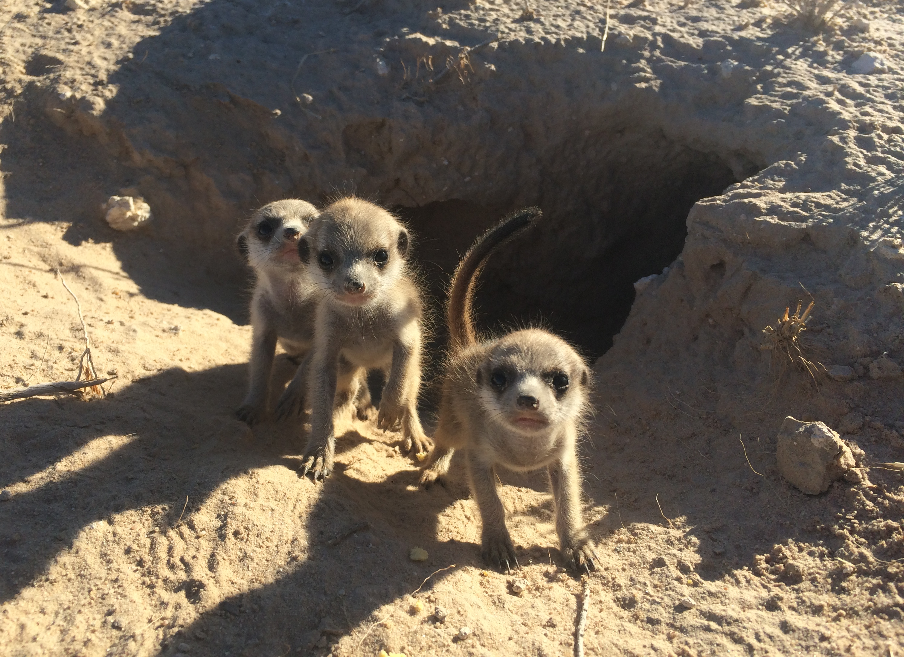
The three youngest members of Elrond’s Council, they have grown since this picture was taken but are still has lovable. Photo Credit: former Meerkat volunteer Chloe Farrington.

The smallest habituation group is Little Creatures, being eight meerkats strong. They have been found and collared in September 2017 for the first time. First only formed by wild individuals, the habituation progress jumped forward when two roving males from habituated groups immigrated in. Indeed, LL Cool J (VLM207) and Watu Porini (VJXM104), both known rovers, were one day found at the group with Watu Porini (VJXM104) being the new dominant. LL Cool J (VLM207) recently disappeared, but the rest of the group is doing great. The dominant male, Kanye (VCRM002), the recently dyed yearling male and the two juveniles are very well habituated. The three other members of the group, another yearling male and two adult females are slowing the habituation process down by being very difficult to work with as they would easily react by going below, but even with this inconvenience, they are progressing step by step by getting used to us a little bit more every session. Having newly born individuals interested in egg or water helps a lot as the adults would be less worried with group members being comfortable with our presence, and these two juveniles are helping volunteers a lot, they would run towards the scales and get very excited!

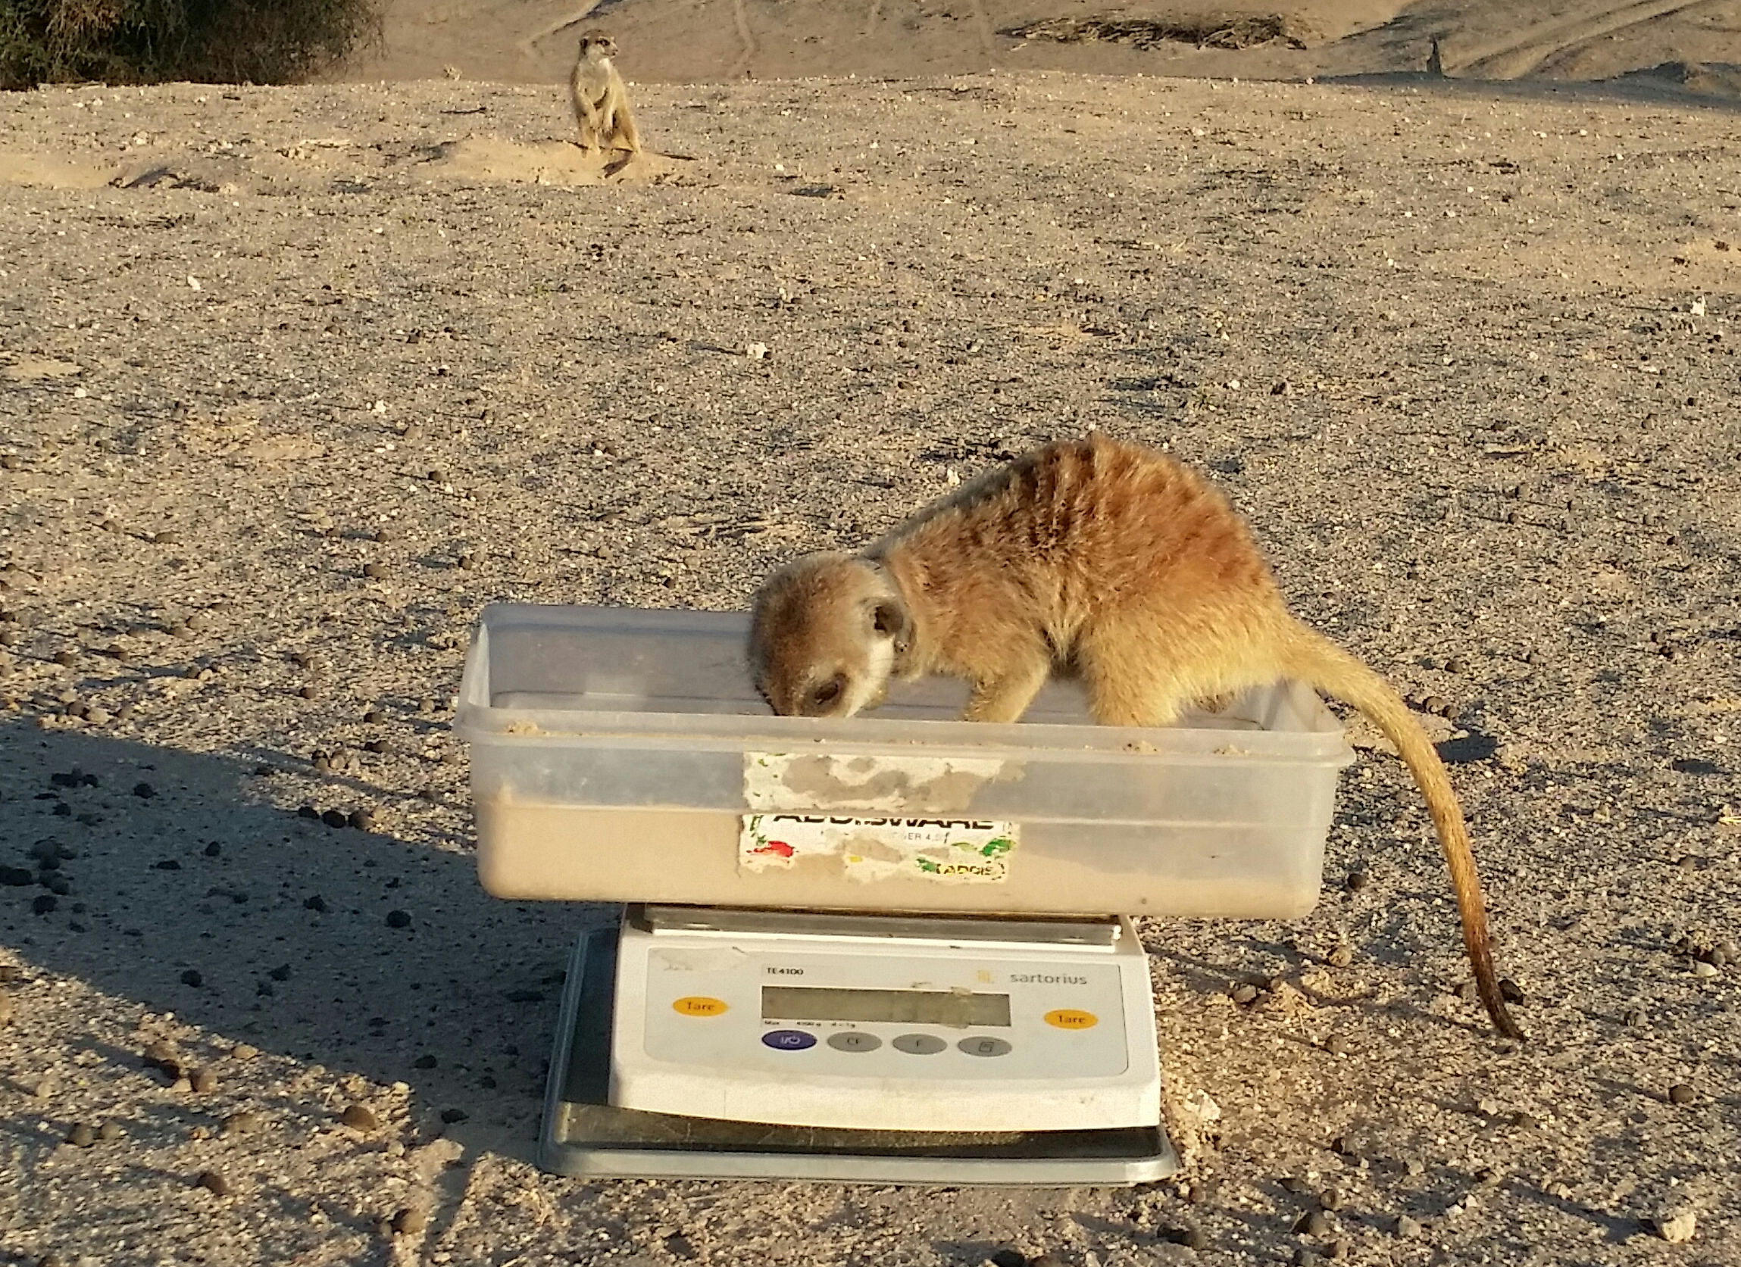
Kanye (VCRM002) in the weights box at Little Creatures, and one of the adult females looking a little bit more worried in the background. Photo Credit: Meerkat volunteer Rebecca Schaeffer.

Tswana, the most recent habituation group has been introduced in the April Meerkatter. The group had a rough start in their history with the KMP, but everything on back on the tracks and the group has proven to be incredibly fast in its habituation process. As a reminder, the first male to be collared has sadly disappeared and the group had been lost. They were found again, and a young female was collared. The eleven of them seem to be evenly habituated, they are comfortable with volunteers sitting at twenty, standing at thirty and moving at thirty from them. In such a short amount of time, Tswana are progressing at an amazing and unexpected speed. The group grew bigger recently, as the adult female, the adult male, the two sub-adult females, the sub-adult male and the three juveniles welcomed four new pups born on the third of June! They have emerged and are now foraging with the group. Sadly, one pup has not been seen in the past few weeks, but all the other ones look more than healthy. Volunteers are going to keep working with them, and are hoping for even more spectacular improvements soon!

Pregnancies in June 2019

Females pregnant in June | 3
Females who aborted | 0
Females who gave birth, litters lost | 0
Females who gave birth, litter emerged | 2
Females who gave birth, unknown outcome | 0
Females still pregnant at the end of the month | 1

Weather at the KMP
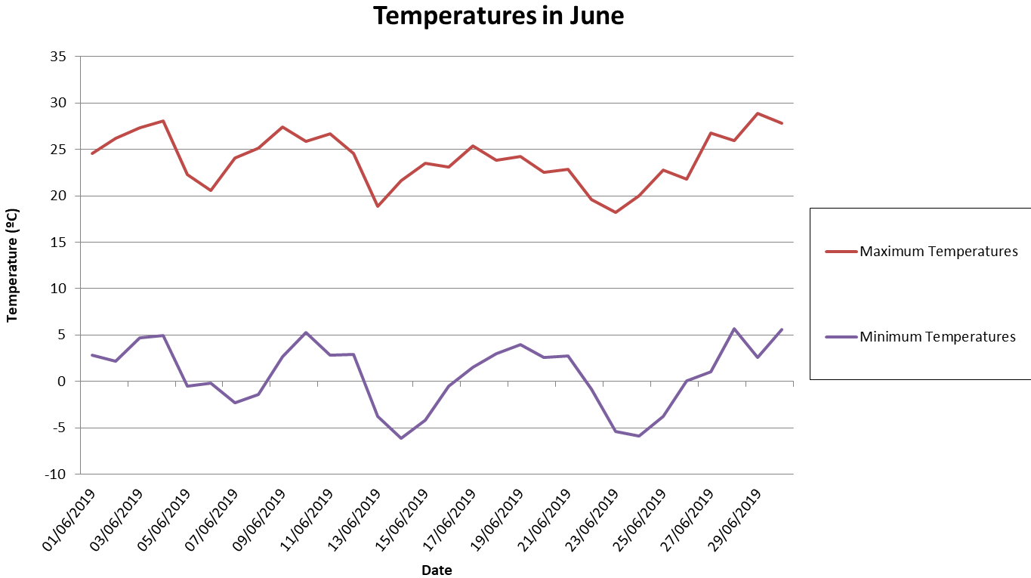
July has registered the coldest temperature the KMP has experienced so far in 2019, with a minimum of -6.2°C. But even with cold temperatures having reached the Kalahari, days are still warm, the highest temperature recorded was 28.9°C. As usual, winter brings cold nights but warm days but winter also brings the driest months, no rain has fallen at the KMP in July!

June 2019 Life History Details

(Little) Creatures:
- LL Cool J (VLM207) has left Little Creatures, has been seen once on the 12th around the group by a volunteer by the members of Creatures had not spotted the roving male. He is still missing at the end of June.
- Habituation is still improving, The Worm’s Heart (VCRM010) is being weighed at each session, and so are the two very good juveniles and Kanye (VCRM002). They are getting more and more confident with use walking around the group. The two adult females and the yearling male are still being shy, but are also improving.
- All members are in good health.

Elrond’s Council:
- A major step has been taking in the habituation process, volunteers have started burrow sit. Usually, habituation groups are only visited in the morning, the goal being to be at the sleeping burro before the group is up and to leave once the group has left. Burrow sits consist of afternoon session where volunteers track the group without approaching, trying to predict which burrow they will return at and wait for the individuals there. At the burrow, normal habituation is performed.
- All members are doing very well and are responding well to the new habituation program. The next focus will need to be the habituation to the equipment, as they are not fully comfortable with it for now.
- The group is in good health.

Gold Diggers:
- It has been a very quiet month at Gold Diggers, no major event has marked the group and habituation is stable. Winter has calmed everything down!
- All members are in good health.

Hakuna Matata:
- Flint Lockwood (VHMF001) is officially pregnant and is waiting for the first litter she will give birth to under her dominance.
- Double Fluff (VHMF010) got evicted, and has appeared three times at the group without being able to come back in. She will hopefully be back as soon as Flint Lockwood (VHMF001) will have given birth.
- Oscar Junior (VHMM016) was evicted for two hours, he stayed at the back of the group and Hakuna Matata chased him away, not realising he was one of their members. He was accepted back in a few hours later.
- Our classic rovers, Dante (VHMM007) left and returned twice, and Guacamole (VHMM008) three times. The group also had an intergroup encounter with Lazuli.
- All members are in good health.

Jaxx:
- One of the pups has disappeared in June, but the five other ones are doing great.
- The group had one daily group split, where Baloo (VJXF080) was found by herself for a little while before re-joining with her group.
- All members are in good health.

Lazuli:
- Three of the Lazuli boys went on adventures in June. Thursday (VLM239) and Fledermouse (VLM242) left and returned twice, Finnick (VLM234) once.
- Dante (VHMM007) and Guacamole (VHMM008) have been encountered five and four times respectively. The group also had an encounter with Hakuna Matata.
- The group are all in good health.

Make-e-plan:
- Bridget (VQLF011) has given birth and three pups have emerged and have started to forage with the group. They were extremely small when they were first seen, they weighed approximately sixty grams! Even with their very small size, they are keeping up with the group and are doing well!
- Crunchy Nut (VMPF006) and Dauphinoise (VMPF007) got back in the group the day after the newest litter was born.
- Khloe (VMPM017) went on a crazy roving adventure, reached Van Helsing and acted like a dominant male at this other group for a few hours, by asserting dominance on males and females! He was back at Make-E-Plan only a few hours later, we will never know what his goal was…
- The group members are all looking healthy.

Namaqua:
- Unfortunately, one of the female pups got separated from the group after an alarm, and was not seen after. The other five pups are still growing stronger by the day.
- Bonnie (VWM209) and Clyde (VWM208) left Namaqua, appeared once at the group and returned a few days later.
- All members seem to be in good health.

Tswana:
- One adult female gave birth in June, the group babysat and females were lactating. A few weeks later, four pups emerged. They are still being babysat at the end of the month.
- Habituation is progressing at a very fast rate, the group is getting more and more comfortable as volunteer reduce the distance separating them from the sleeping burrow. They seem to be comfortable at twenty to thirty meters, which is surprisingly short for a group that entered the program that recently.
- The group looks healthy.

Ubuntu:
- Many of the Ubuntu members took off to explore the surroundings in June! Mr Bojangles (VUBM015) left and returned once, Meticulous Brown (VUBF019) left running behind a wild male the group had an encounter with before coming back, Bon-Bon (VUBM016) and Shrew (VUBM018) left and returned twice both.
- Ubuntu has also encountered a few meerkats from other groups, Guacamole (VHMM008) twice, Fledermouse (VLM242) once, and unknown individuals four times.
- Scar (VUBM021) is now weighable, he loves egg and water and is being more and more curious towards volunteers.
- All members are in good health.

Van Helsing:
- Van Helsing are still counting six original members born into the group, and five wild males, their habituation is improving by the day.
- Kaylee (VVHF110) was evicted at the end of May and is still by herself, sometimes seen around the group. She is still suffering from severe TB symptoms.
- Van Helsing got the visit of Khloe (VMPM017), staying at the group for a few hours and acting as a dominant male, females and males from Van Helsing were even submitting to him. He was gone the very next session session.
- The two yearling females, Tim Tam (VVHF127) and Quincy (VVHF129) both suffer from TB symptoms that seen to get more and more severe very rapidly. The present open lumps, limps, fatigue and are skinny.
- The juveniles seem to be healthy, and so are the wild individuals.

Whiskers:
- Three healthy pups have emerged and are now foraging with the rest of the group that is taking very good care of them.
- All members look healthy.

Zulus:
- The two little pups started with being a little bit worried about volunteers, but are now some of the friendliest little meerkats in our population!
- Sauce (VZUM026) left the group ten times (yes, ten!), and returned nine times, he is absent at the end of June. Palestrina (VLM221), the dominant male, left and returned once.
- Zulus encountered a wild meerkat twice, and chased the individual away.
- The group is looking healthy.

The following authors contributed to this report:

Lucie Reinwalt, Life History

Group Territories June 2019

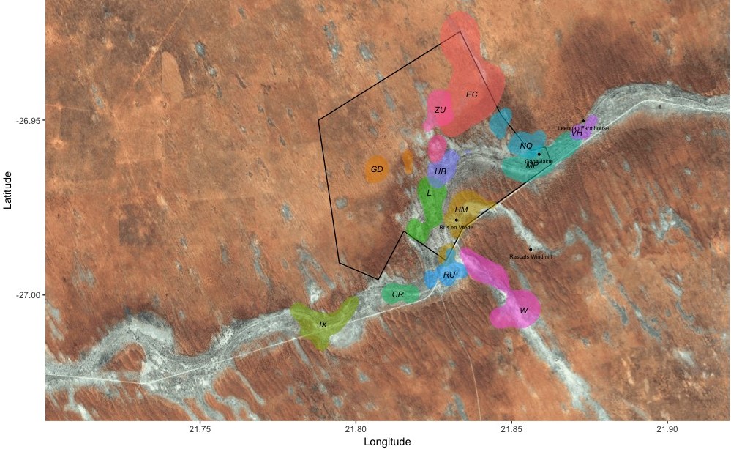
Key: CR: Little Creatures, EC: Elrond’s Council, GD: Gold Diggers, HM: Hakuna Matata, JX: Jaxx, L: Lazuli, MP: Make-e-plan, NQ: Namaqua, UB: Ubuntu, TS: Tswana, VH: Van Helsing, W: Whiskers, ZU: Zulus.

